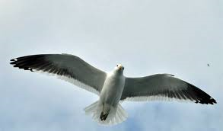
SEAGULL

SOIL ROCKS

FOREST RIVER
ESTUARY FIELD

FRESHWATER PUDDLE

SALTWATER PUDDLE

SEA DESERT

MOUNTAIN

