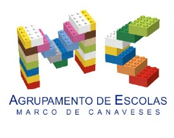
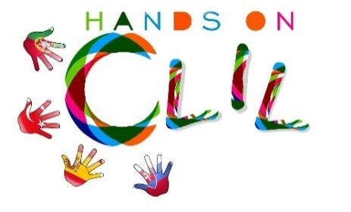

CLIL LESSON PLAN
CLIL PATHWAY: Arts and Maths | LEVEL: Pre-school
CLIL MODULE: Healthy diet | CLIL TOPIC: Eggs are good and fun!
LESSON: 4 | TIME: 45m
TEACHING AIMS | MATERIALS
- develop their creativity and their fine motor skills;  - develop math awareness and skills - numbers and counting skills;  - respect others when playing in group | - egg boxes  - scissors  - coloured pencils  - paint  - polystyrene foam balls  - chicken paper templates  - dice
LEARNING OUTCOMES - 4Cs
CONTENT | COGNITION
- explore colours and textures  - to colour  - to cut out  - to count  - associate number and quantity | - recalling the character “Chicken” from the story “Jack and the Beanstalk”;  - applying knowledge when producing a game;
CULTURE | COMMUNICATION
- understand the importance of a healthy diet;  - memorize and recall a traditional tale; | Language Function: Listening / Speaking / Spoken Interaction  Vocabulary: healthy food, egg, chicken/ vocabulary related to “Jack and the Beanstalk”/ vocabulary related to Arts and Crafts  Verb(s): imperative for instructions and present simple - to be/ to have got/ to listen/to prepare/ to eat/ to like/ to look /to put/ to colour/ to cut out/ to stick/ to count/ to paint  Language structure: What’s the weather like? / What day is it today? /What’s the temperature?/ What time is it? What’s this? This is…/ Let’s…/ Do you like…? Yes, No…/ Is it…? Yes, No.
ACTIVITIES
Step 1 – to tune pupils into English the teacher acts according to the usual morning routine (check lesson plan 1);
Step 2 – the children think of what activity to do according to the classroom activity chart while the teacher presents them the new activities for the day related to the character “chicken of the golden eggs” from “Jack and the Beanstalk”– making the chicken game parts (please see the photos);
Step 3 – the learners who chose the chicken game activity will paint egg boxes (two boxes of six per child) and polystyrene foam balls/eggs (twelve per child); colour and cut out a chicken template and then stick it on the egg boxes and paint the eggs.
Step 4 – end of the lesson according to the end of the morning routine – the teacher rings the bell and the class goes to the toilet to prepare for lunch.
EVALUATION
- Immediate feedback after oral classroom report

Author | School: Mrs Júlia Soares/ Mrs Olga Susana
JI Ramalhais
2017/2019

