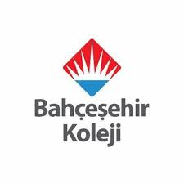
PRE /POST-TEST in PHYSICAL EDUCATION – Physical movements
The aim of this questionnaire (Knowledge Assessment Questionnaire) is to assess the impact of Science Content Learning by means of bilingual methodology within Primary Education.
1. I know shapes.
Pre - A lot A little Not at all
Post - A lot A little Not at all
2. I can identify the different shapes
Pre - A lot A little Not at all
Post - A lot A little Not at all
3. I can write these verbs.
Pre - A lot A little Not at all
Post - A lot A little Not at all
4. I can Show shapes
Pre - A lot A little Not at all
Post - A lot A little Not at all
5. I can select some verbs in charts.
Pre - A lot A little Not at all
Post - A lot A little Not at all
6. I can pronounce these verbs easily.
Pre - A lot A little Not at all
Post - A lot A little Not at all
7. I can make sentences these verbs.
Pre - A lot A little Not at all
Post - A lot A little Not at all
8. I can write these verbs at the blackboard.
Pre - A lot A little Not at all
Post - A lot A little Not at all

