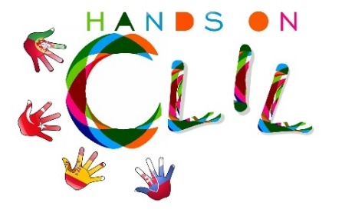
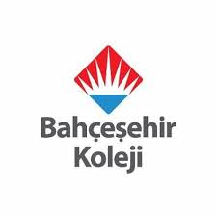

CLIL LESSON PLAN
CLIL PATHWAY: ART & CRAFT | LEVEL: 1st Grade
CLIL MODULE: Shapes | CLIL TOPIC: Shapes
TEACHING AIMS | MATERIALS
- To recognise the different shapes  - To identify the different food groups and its main nutrients  - To recognise written form of key language  - To build short sentences | - Flashcards of shapes  - Songs  - (https://www.youtube.com/watch?v=lcl8uB2AWM0)  - Hopscotch  - Stick  - Coloring papers
LEARNING OUTCOMES - 4Cs
CONTENT | COGNITION
- To identify the different shapes  - To recognise written form of key language | - Identify and sorting shapes
CULTURE | COMMUNICATION
- Develop awareness about shapes with physical  education. | Language Function: Talking about shapes  Vocabulary:  - Triangle, circle, oval, square, heart, star, rectangle  Verb:  - am / is/ are  Language structure:  - It is …  - I am
ACTIVITIES
Step 1 – To tune pupils into English
- Teacher /pupils greet each other in English.
- T asks some warm up questions like How is the weather ?

Step 2- To help pupils understand what the lesson is about
- Teacher tells pupils what they are going to do. T shows some flashcards about shapes. Sometimes teacher asks them to show shapes by looking around.

Step 3 – Post activity
- Teacher brings class hopscotch, asks them to jump and say the shapes.

STEP 4-

- T gives students coloring papers about shapes.
- After coloring, students cut the paper appropriately.
- Then, they attach the paper on a stick for making shape mask.
- At the end they make sentences like I’m a rectangle, I’m a circle….

.
Step 5 To end lesson
- Teacher say goodbye to students
EVALUATION

