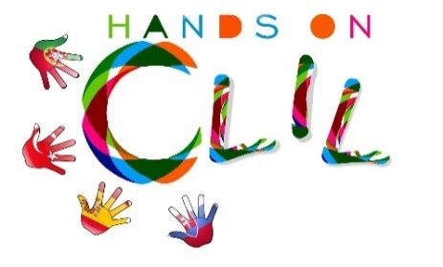
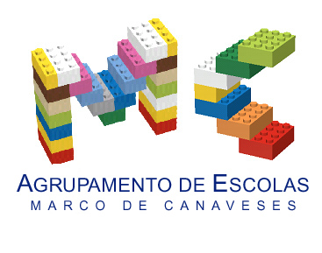

CLIL LESSON PLAN
CLIL PATHWAY: SCIENCE | LEVEL: Pre-school
CLIL MODULE: Healthy diet | CLIL TOPIC: Beans – how do they grow?!
LESSON: 1 | TIME: 60m
TEACHING AIMS | MATERIALS
- raise awareness on the importance of legumes in a good health;  - understand a story and name the main characters;  - learn new vocabulary related to healthy food;  - understand how plants grow and survive;  - develop/improve creativity;  - develop fine motor skills and hand-eye coordination. | - realia: beans, peas, chickpeas, broad beans, lupins  - Jack and the beanstalk – paper characters  - yogurt containers  - cotton  - water
LEARNING OUTCOMES - 4Cs
CONTENT | COGNITION
- name and describe (size and colour) selected legumes | - classify types of food  - identify different types of legumes  - understand the basic plant growth needs
CULTURE | COMMUNICATION
- understand the importance of a healthy diet | Language Function: Listening / Speaking / Spoken Interaction  Vocabulary: days of the week; months; numbers; weather/ legumes - peas, chickpeas, broad beans and lupins; colours; adjectives big, small; healthy food; diet; mother; giant, giantess, cow, magic beans, castle, chicken, golden eggs/ cotton balls, yogurt container, water, window, light, growth  Verb(s): imperative for instructions and present simple - to be/ to have got/ to listen/ to eat/ to like/ to look/ to sell / to climb/ to run /to grow/ to put/…  Language structure: What’s the weather like? / What day is it today? /What’s the temperature? / What time is it? What’s this? This is…/ Let’s…/ Do you like…? Yes, No…/ What colour is it? / Is it big/small…?
ACTIVITIES
Step 1 – tune pupils into English with the morning classroom routine – the class helper will set the classroom date, weather and time charts with the help of the classmates (video – morning routine);
Step 2 – To help pupils understand what the lesson is about – the teacher talks with the children about World Food Day and together they name healthy and unhealthy examples of food;
Step 3 - The teacher shows different types of legumes to the children – beans (different colours and sizes), peas, chickpeas, broad beans and lupins and together they identify them, share their likes and dislikes and say if they eat them on regular basis. The kids hold them and observe them. The teacher highlights their importance in a healthy diet.
Step 4 – The teacher shows the book “Jack and the beanstalk” and asks if the children know the story. The teacher invites the children to watch a play of the story «Jack and the beanstalk». (video - play). At the end with the help of the teacher they will name the main characters – Jack, the mother, the giant and the giantess- and other important elements like the cow, the magic beans, the castle, the chicken and the golden eggs.
Step 5 – The teacher asks the children if they would like to grow beans at school and explains the experiment process - each one will choose one bean and they will wrap it in a cotton ball, place it in a yogurt container, water it and then place the container by the window. They will talk about what the bean seeds need in order to grow – water and light. They agree to check on their container everyday to see the changes…
Step 6 – To end lesson according to the end of the morning routine – the teacher rings the bell and the class goes to the toilet to prepare for lunch.

EVALUATION
- Immediate feedback after oral classroom report

Author | School: Júlia Soares/ Susana Soares
JI Ramalhais
2017/2019

