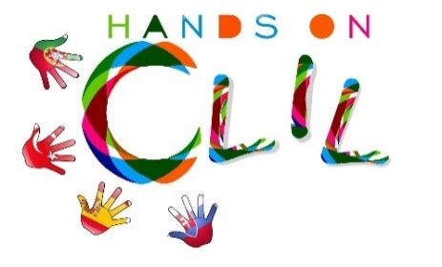

CLIL LESSON PLAN
CLIL PATHWAY: SCIENCE | LEVEL: 3
CLIL MODULE: The amazing World of Science | CLIL TOPIC: Thermometer
LESSON: 1 | TIME: 45 min
TEACHING AIMS | MATERIALS
- to understand instructions  - to name the objects needed for experiment  - to describe experiments  - to create pupils’ own poster of experiment | - ink  - a small plastic bottle with cold water  - some modelling clay  - a straw  - a bowl  - cold water  - a kettle with hot water  - worksheet  - colouring pencils
LEARNING OUTCOMES - 4Cs
CONTENT | COGNITION
- to understand instructions  - to describe experiment successfully | - to name the objects in English  - to describe the steps of experiment  - to understand how does the thermometer work  - to design the poster
CULTURE | COMMUNICATION
- to recognise importance of safety rules | Language Function:  -talking about the effect of hot water on cold water in a bottle  Vocabulary:  -a straw, a bottle, modelling clay, hot/cold water, a bowl, a thermometer  Verb(s):  -repeat, put, name, say, listen, read, watch, draw, join, start, hold, rise  Language structure:  Put the straw in the bottle.  Put the modelling clay around it to hold it in place.  Put hot water into the bowl.  Put the bottle into the bowl.  The water in the straw rises.  It´s a thermometer.  I like English and Science.
ACTIVITIES
Step 1 – To tune pupils into English
Teacher/pupils greet each other in English
Step 2 – To help pupils understand what the lesson is about
Teacher tells pupils what they are going to do.
First they fill in the pre-test.
Step 3 - Warm-up activities and song Cold and hot
What´s the weather like today?
What´s the weather like in summer?
What are you wearing in summer?
What´s the weather like in winter?
What are you wearing in winter?
What do you prefer- winter or summer? Why?
Do you like wearing jacket? Put on your jacket (do the action) Take off your jacket (do the action)
Do you like wearing hat? Put on your hat (do the action) Take off your hat (do the action)
Do you like wearing mittens? Put on your mittens (do the action) Take off your mittens (do the action)
Step 4 – Pronunciation and spelling of objects
Focus on the spelling of the objects.
Teacher presents flashcards or real objects and pupils repeat the vocabularies.
Vocabulary:
-a straw, a bottle, modelling clay, hot/cold water, a bowl, a thermometer
Let´s play SPELLING SHARK
Imagine some word and write two lines of spots on the board (each spot for each letter). At the end of the line draw the simple picture of the shark.
Players guess the letters. Teacher writes them on the board-those which consist of the imaginary word - on the correct spot on the top line and those letters which are not in the secret word somewhere else on the board. For each incorrectly guessed letter draws the picture of the little man on the bottom line of the spots. If the class guesses all letters of the word faster than they are filled up in the spots, pupils clap their hands. If not shark will eat the little man.
Step 5 – To demonstrate the experiment
Teacher tells the pupils that they are going to make a thermometer.
Teacher demonstrates the experiment according to following instructions.
What do we need? What´s this?
Instructions:
Put the ink into the bottle of water.
Put the straw in the bottle.
Put the modelling clay around it, there must not be any place for the air.
Put hot water into the bowl.
Put the bottle into the bowl.
The water in the straw rises.
It´s a thermometer.
Step 6 – To work on your own
Pieces of worksheet with instruction:
- Draw and colour the pictures into the empty squares.
Step 7 – Speaking comprehension and presentation
Pupils tell information about the experiment to each other. They describe it. Then they act it.
Step 8 song
Pupils sing a song Cold and hot
Step 9 – To end lesson
Pupils tidy up and say the farewells in English.

EVALUATION
- Immediate feedback after oral classroom report
- Completion of post-test

Author | School: ZŠ Škultétyho 1, Nitra

