Lesson Plan: Title

Information

School: ZŠ a MŠ Ostrava-Zábřeh, Kosmonautů 15
Students: 14 years old, Natálie Hašková, Veronika Polcrová, Tereza Jasníková, Michaela Hladká, Michaela Janáčová, Klára Šmirová, Nikol Bystroňová, Patrik Pavlíček

Subject: Music
Vocal practice, song “Falling slowly”, explanation of the Czech background, song awards, lyrics, tune

Goals (targets, results):
To enlarge vocal abilities of pupils
To teach about Czech young singer Markéta Irglová who composed piano part for the Oscar winning song “Falling Slowly” from the Irish music movie “Once”. The song was written and performed by Glen Hansard and Markéta Irglová in the film Once in 2006 when Markéta was 18 years old. The film was played since 2007 and it got popular on the film festival Sundance in 2007 where it was got the spectators award. In February 2008, the romantic song was awarded by Music Oscar for the song first published in 2007.
To show students that young people can be successful and to encourage them to reach their dreams

Means:
A vocal practice – electronic piano, guitar, data projector, laptop, powerpoint presentation of the “Falling slowly” song lyrics and its background, the Internet

Description

Begin:
1° activity: Vocal practice to warm up the voice cords, 10 minutes
Students welcome to their lesson and introduce the first activity which is important for warming vocal cords and increasing their range. First the students explain the importance of the activity; next they show how to make the humming sound. Then the melody is given by the electronic piano and students copy it by humming. Finally the pupils – Erasmus project participants are asked to join in. The procedure is repeated approximately 3 times, the tune is varied and the range changes. In the last exercise, the melody is sung with syllable “La”.
The video of a part of this activity from the lesson: https://www.youtube.com/watch?v=rRuws3kl9hQ
2° activity: Background of the chosen song “Falling slowly” – powerpoint presentation of the lyrics, the Internet is used to show pictures, 5 minutes
Students introduce the chosen song “Falling slowly” which was written and composed by Irish composer and songwriter Glen Hansard and 18 years old Czech girl Markéta Irglová. The main melody was created earlier, but Glen forgot it and later it was Markéta who remembered it and wrote the the part for the piano. This romantic song was used in the music film “Once” which was made in 2006 and both Glen and Markéta sang this song and performed the main characters. This film was first played in the cinemas in 2007 and it was rewarded by spectators’ award on the Sundance festival in 2007. This success made this film famous. The song “Falling slowly” was awarded by Oscar for music in 2008. The young talented Czech pianist, composer and singer Markéta Irglová became popular and she showed young people that it is possible to make their dreams true and do for living what one really likes.
Show the photos of Markéta Irglová and Glen Hansard, film “Once”:
http://4.bp.blogspot.com/-lmBo_cLLLPI/T0cB4msJAbI/AAAAAAAAAP8/if3-tunyApY/s1600/2007_once_010.jpg
More in the article: http://www.foxsearchlight.com/post/1299/actor-musicians-glen-hansard-and-marketa-irglova/

3° activity: Singing the song by Czech students, 5 minutes
Czech students sing the song; they are accompanied by the electronic piano and the guitar.

4° activity: Learning the tune, singing the song, 20 minutes
First the Erasmus pupils read the lyrics together, data – projector and powerpoint presentation are used. Then the melody is played and the song is sung together. After singing the first verse, the feedback is given. Then the song is sung again from the beginning. The electronic piano and guitar are used to play the melody. The guitar is played by Czech student; the electronic piano is played by the Czech teacher. There is a student who can play it but she is involved in singing and she feels nervous about singing the English song and playing at the same time in front of the international auditorium.
Falling slowly, eyes that know me
And I can't go back
Moods that take me and erase me
And I'm painted black
You have suffered enough
And warred with yourself
It's time that you won
Take this sinking boat and point it home
We've still got time
Raise your hopeful voice you had a choice
You've made it now
Falling slowly sing your melody
I'll sing along
I don't know you
But I want you
All the more for that
Words fall through me
And always fool me
And I can't react
And games that never amount
To more than they're meant
Will play themselves out
Take this sinking boat and point it home
We've still got time
Raise your hopeful voice you have a choice
You've made it now

Read more: http://www.metrolyrics.com/falling-slowly-lyrics-glen-hansard.html
http://www.metrolyrics.com/glen-hansard-pictures.html
http://www.karaoketexty.cz/texty-pisni/irglova-marketa/falling-slowly-16754

Experience

Try-out: 2014-01-26, Ostrava
Lesson1: 12:05 – 12:50 The students are in class with Erasmus+ project meeting participant from 5 countries who attend middle schools,16 - 17 years old, they know some English very well.

Evaluation

Students:
Klára: I was a little bit afraid but singing was really great, everything was as we planned. We had fun during work on the lesson and enjoyed the lesson with our guest.
Michaela: I think that it was a good idea to do the music lesson and I think that the others enjoyed it too.
Michaela: It was super even though we were reading our comments from the paper, it looked very unprofessionally. In spite of that I think that it was great and we enjoyed teaching the song.
Teachers:
Pupils:
Pupil from Ireland: I myself love to play the harp and to sing, so the most inspiring part of the meeting for me was when the principal played the piano and we sang. I thought he was amazing.

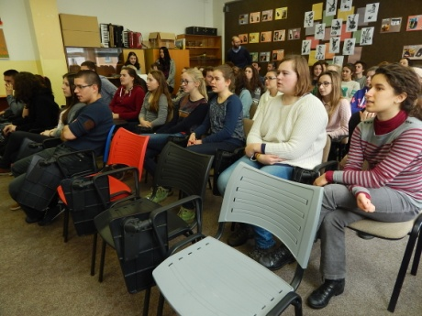
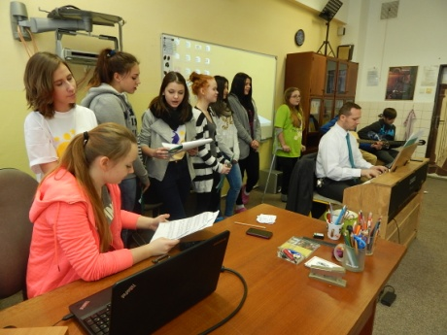
Some photos from the lesson:
