*EUROPE*

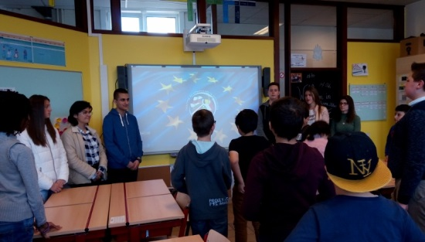**School:** “Vasil Levski” high school, Sevlievo, Bulgaria  
**Students**: Katerina Shopova, Iveta Boteva, Simeon Gelovski , Polina Georgieva, Angel Gotsov, Kristina Petkova, Cvetelina Coneva .  
**Subject:** Geography of Europe, European capitals, landmarks, politics  
**Goals:** That they know more about each country and its landmarks.  
**Means:** Presentation for Europe, playing worksheets, crowns and flags of the countries for playing a game.  
  
Description  
  
**Begin:**  
 1)We start with our presentation “One day along Europe”. It contains each of the six countries that take part in our project. Also their capitals and two most visited landmarks. There are a lot of pictures and videos that make more interesting the learning process.

<https://www.youtube.com/watch?v=uwC-M3j8nAg>

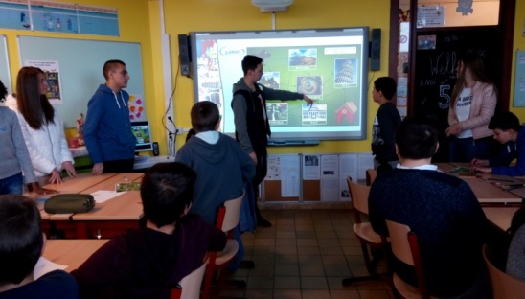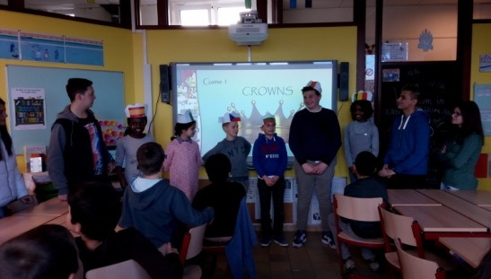  
 2) **Activity:** A game with crowns – 10 min  
We start with choosing 6 students, after that we put a crown on each student. The crowns have flags on them of each country that take place in our project. Then we made them to take in alphabet order without knowing which flag they have. After that they should be in scale order. The biggest country must be 1st.

3) **Activity:** A game with flags – 10 min  
We separate the class in 6 groups, each group have a sheet of paper. On this sheet there are six flags on every country. 1st they must connect every country with its capital city and then they must colour fill the flags in appropriate color. The 1st group win the game.

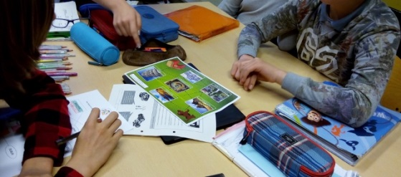 4) **Activity:** A game with lost dog searching home – 10 min  
Every group have sheet of paper where a dog have lost his way back to home. To find the way students must decide which one of two landmarks is in the pointed country. There are pictures and they should recognize which one actually exist in this country. 1st one is the winner.  
  
Experience  
  
**Try**-**out**: 25.04.2017, Berkenboom Humaniora



**Lesson 1**: 9:00 - 9:45 . The students are in class 2a, 12 years old and know some capitals and landmarks. They can read.  
 **Lesson** 2 : 10:00 -10:45 . The students are in class 2g, 13 years old and know some flags.Some can read.

20.04.2017 in SU “Vasil Levski”, class 5g

Evaluation

**Students**:

*Katerina*: I had a very nice experience educating the little children. It was lovely to see that the learn while having fun. I think the will remember all six flags because they did great job!  
*Iveta*: I found it fun to teach students in different way. I think that our group did awesome job during the project, and finding a new for teaching pupils was not easy but lovely.  
*Simeon*: It was such a amazing experience in my life. I hope all pupils have learned at least one thing about every country.

*Teacher Daniela Dimitrova*: Students chose the lesson ideas and methods. They made the presentation and the games themselves. I think they were a little worried at first, but everything went well and they enjoyed this experience.