


Teaching: An effective key to self-learning
This project is funded by European Union
Art in Physics

Question: Is the density of liquids same in the same conditions? Answer: a) Yes b) No

Experiment 2: A homemade Lava Lamp experiment
http://reekoscience.com/science-experiments/floatation/make-a-homemade-lava-lamp
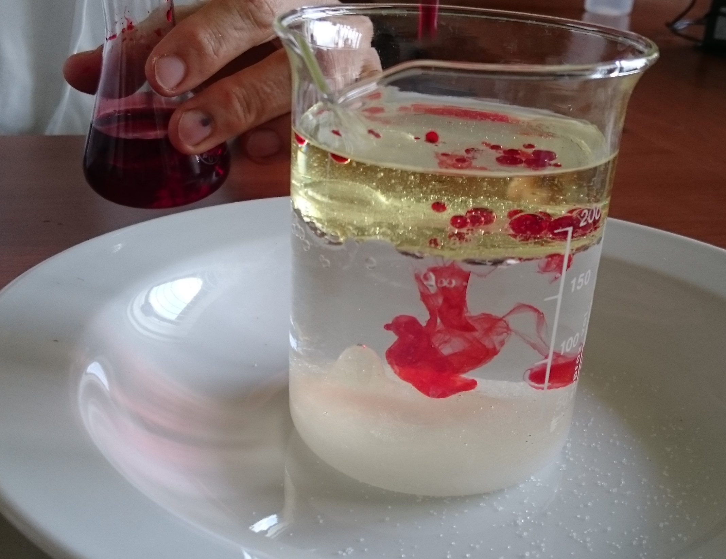
Ingredients: water, vegetable oil, salt, food dye
Equipment: a glass jar, a dropper, a spoon
Instructions:
Fill about 2/3 of a glass jar with water. Add just enough of vegetable oil to form a layer on top of the water and wait until the different layers settle. Next add a spoon of salt, shake gently salt into the jar for five seconds. What can you see? Add another spoon of salt in the jar, this time sprinkle it fast. Compare the first and second reaction. Now you can add drops of a food dye. What happens? Add another colour. What can you see now? You can add more salt to restart the reaction.
What happened? Draw lines to make true statements about it:
When we sprinkled the salt into the jar, the salt melted in the oil layer and dissolved there.
the salt formed a glob and sank to the bottom.
The bubbles floating up were formed by the air which the falling salt mixed in the liquids.
the oil which covered the salt glob, which slowly dissolved in water.
The way how fast we sprinkled the salt made a little difference to forming globs.
made a significant change in forming globs.

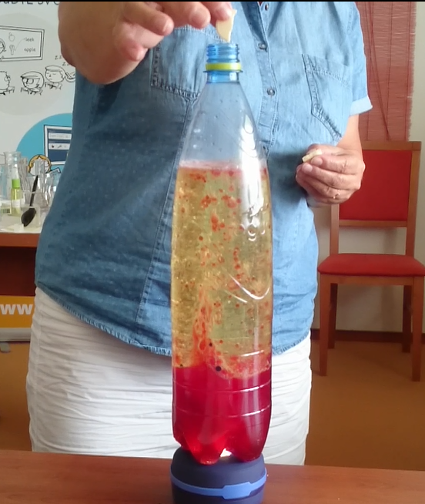
Experiment 3:
http://debrujar.cz/clanek/2014100004-lavova-lampa-experiment

Ingredients: water, vegetable oil, food dye, CO₂ (citric or ascorbic acid)
Equipment: a glass jar, a dropper, a bottle
Instructions:
Fill about 1/3 of a bottle with water. Add vegetable oil almost to the top and wait until the different layers settle. Next add drops of food dye, you can use more colours. Watch what the drops will do. After a while add 1or 2 effervescent tablets (or add melted citric or ascorbic acid in little water). Add more tablets to restart the reaction. What happens?

Explain why the heavier coloured water floats up through the oil to the surface but does not stay there:

Lava experiments:
In these science experiments, you could create a real working lava lamp. Lava lamps were very popular in the 1970’s. People enjoyed watching colourful liquid in a bottle which was swirling aimlessly around. These lamps became popular again a few years ago. They are used to demonstrate the scientific principles of immiscible liquids (liquids that won’t mix). Some teachers use them to explain density of liquids. During the second reaction is released CO₂ which floats slowly up and pupils can better observe bubbles especially if they colour the water first.

Scientific background (How does it work?):
The oil floats on the water because it is less dense (lighter) than the water. Oil doesn’t mix with water either so it will not dissolve into the water. The salt however, is denser than water and heavier. When you shake the salt onto the oil, it clings to the oil and after a bit of it piles up, drags the denser glob to the bottom of the jar. Salt also will dissolve in water. After a while, the salt begins to dissolve in the water until it reaches a point where it can no longer hold down the glob of oil – the glob floats back to the surface where you can sprinkle more salt on it and repeat.
Tips:
In the last experiment, replace water with vinegar and use soda to produce CO₂ for your lava lamp.

Test:
a) What happened when you added salt in the jar?

b) Why did the lighter oil go down in the heavier water?

c) The drops of food dye coloured water but didn´t change the colour of the oil. Why?

d) Bubbles of heavier water floated up to the surface through the lighter oil. Why?

e) The coloured bubbles floated up. When the reaction ended after a while there was only oil in the upper layer. Why?

f) Compare both lava experiments:
What was the same?

What was different?

