European Values: FAIRTRADE – student worksheet

1) Make little groups of 3 – 4 pupils and answer these questions:
a) Explain what “Fair-trade” is: .................................................................................................................
...................................................................................................................................................................
b) Which Fair trade products do you know? ............................................................................................
c) How are most of the Fair-trade products made? .................................................................................
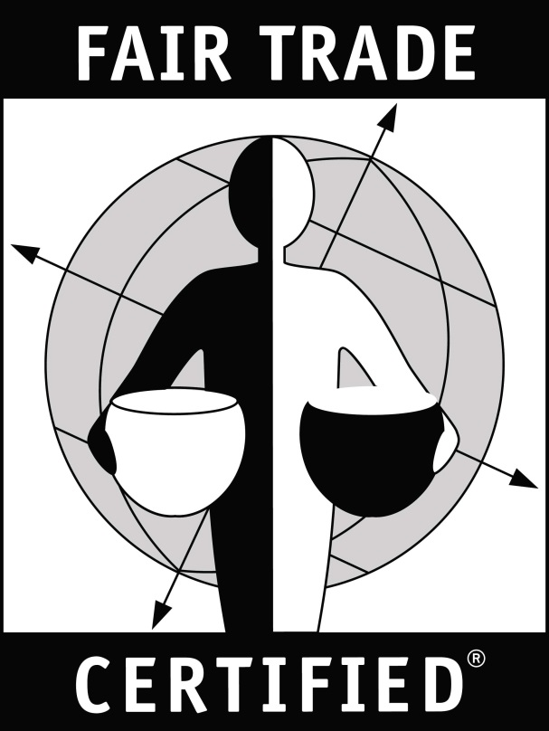
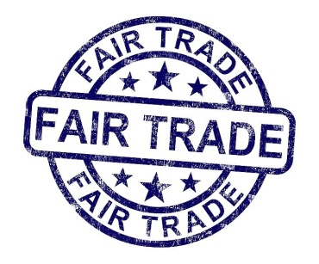
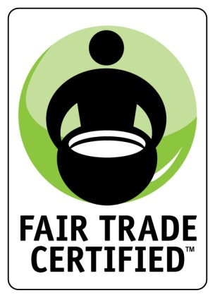
2) Which of these pictures represents Fair-trade logo?
a) b) c) d)

3) Read the text in the box. Then check your answers from task one.
Name “Fair-trade” was first used in the Netherlands in the 80s in the last century. Max Havelaar Foundation introduced the first product fulfilling the Fair trade criteria, coffee from Mexico, in 1988. The first Fair trade organization was founded in Great Britain in 1992 and its first products with Fair trade logo were produced in 1994. The first Fair-trade products were connected with handmade goods, nowadays the most traded Fair-trade goods are coffee, cocoa, sugar, and tea. The seat of Fair-trade is in Bonn and its main goal is to set the Fair-trade certification standards, to give the minimum price for the Fair-trade goods, promotion of Fair-trade logo, organizing campaigns for support of the fair trading. One half of the elected board are representatives of the Fair trade cooperative producers mainly from the developing countries.

3) What do you know about tea? Where is it grown? How is it changed into the tea which we drink? Why is tea important for people? Then watch presentation and check with your ideas.
..................................................................................................................................................................
..................................................................................................................................................................
..................................................................................................................................................................
Check your answers for tasks 1, 2, 3: http://www.slideshare.net/alenaholas/presentation-fairtrade-tea
4) Answer these questions then watch presentation:
a) Do you know where you can buy Fair-trade product in your town? Where?
..................................................................................................................................................................
b) Have you ever bought a Fair-trade product? What was it? .................................................................
c) Here is a list of Fair-trade products. Choose five which you are most likely to buy:
chocolate, juice, cocoa powder, clothes, juice, bananas, tea, sugar, nuts, coffee, rice, dried fruit
..................................................................................................................................................................
d) What do you know about cocoa? Is it a plant, a bush or a tree? ....................................................
e) Chocolate seeds are covered by .............. leaves to dry. They dry at .............°C.
f) Look at task c, which of the products were the most popular in the Czech Republic in 2008?
..............................................., ..............................................., ...............................................
g) How often people buy the Fair-trade products? Match the frequency and the number:
Never I am not sure Yes, but rarely Sometimes Regularly
7% 15% 19% 24% 36%

h) How much has declined child labour since 2 000? By one half / By one third / By one quarter
i) How many million children have to work? Less than 100 / more than 100 / more than 200
j) How many children must do hazardous work? One quarter / One third / One half
k) Where is the highest child labour? Match the areas with number of working child population :
Latin America and the Caribbean Middle East and North Africa Sub-Saharan Africa
9.2 million (8.4%) 13 million (8.8%) 59 million (over 21%)

l) How many children work in the most important sectors, mostly in the informal economy?
12 million 54 million 98 million (59%)
Agriculture Industry Services
m) Fill the words in brackets in the gaps: Child labour among .............. fell by 40% since 2 000, compared to 25% for .................. . (boys / girls)
n) Write some reasons for buying Fair-trade products:
..................................................................................................................................................................
..................................................................................................................................................................
Watch and check your answers: http://www.slideshare.net/alenaholas/presentation-of-fairtrade-products

