


Teaching: An effective key to self-learning
This project is funded by European Union
Art in Physics

Question: Is the surface tension same in different liquids? Answer: a) Yes b) No

Experiment 1:
Ingredients: water, fat milk, oil, ground pepper, liquid food dye, washing-up liquid or a bar of soap
Equipment: 3 plates or bowls, ear sticks or toothpicks, a dropper

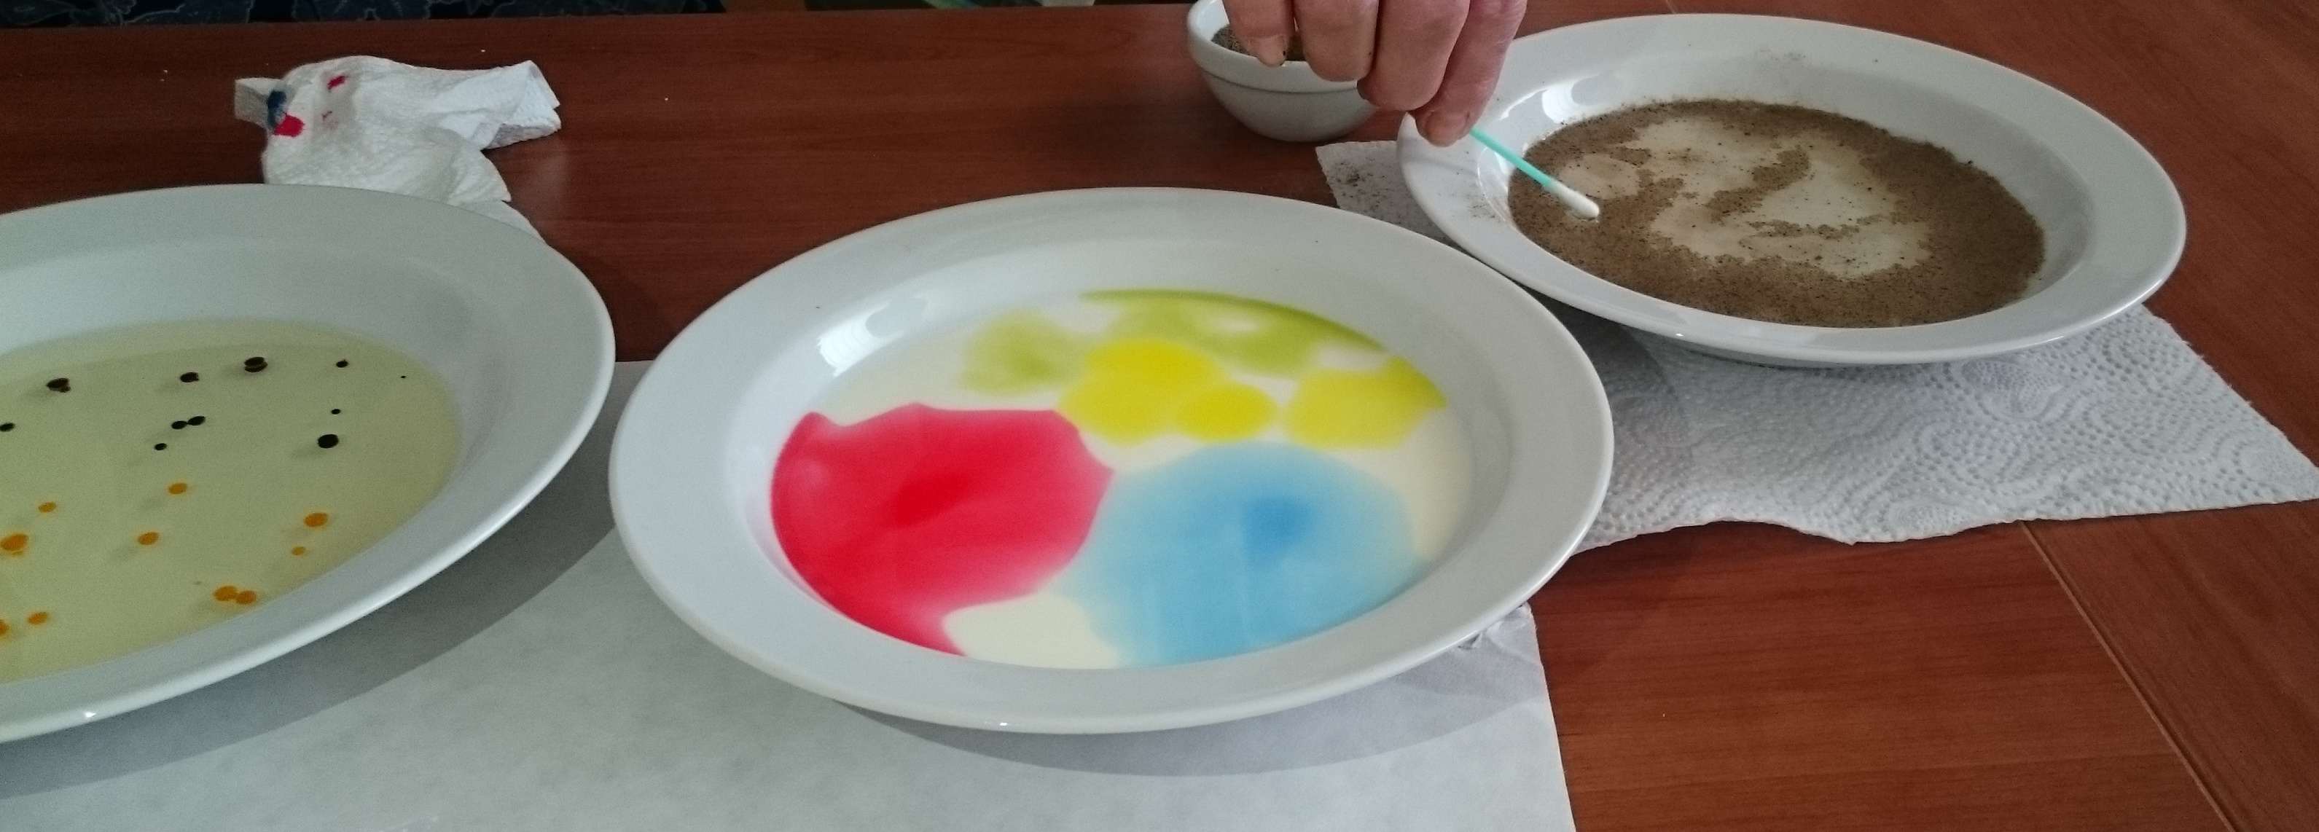
Instructions:
a) Half fill a small bowl with water. Then sprinkle a thin layer of ground pepper on the surface. Next touch the water with a toothpick. After this dip another toothpick in washing-up liquid. Then touch the middle of the water with the stick´s tip. As the washing-up liquid touches the water, watch the grains of pepper. What happens to them?

What happened? Draw lines to make true statements about it:
Pepper instantly disperses to the sides of the bowl if the clean toothpick touches water surface.
Pepper grains do not move away if a toothpick is dipped in washing-up liquid

b) Half fill another small bowl with milk. Then add two or three drops of liquid food dye in different places. Use several colours if you have them. Touch the milk and the colour spots with a toothpick. Next dip another toothpick in washing-up liquid and touch the colour spots in the milk. What happens to the dyes as you do this? You can touch the colour in several places. Then draw the stick in milk.

What happened? Draw lines to make true statements:
Drops of food colour disperse in milk immediately.
do not mix with milk easily.
The food colour moves away if we touch it with a clean stick.
if we touch it with a stick covered with washing-up liquid.
The different colours blend if we draw with a clean stick through colours and milk.
if we draw with a stick covered with washing-up liquid.

c) Half fill the third small bowl with oil. Then add two or three drops of liquid food dye in different places. Use several colours if you have them. Dip a clean toothpick next to the coloured spots and then draw the toothpick through the colour spots. Next repeat with the toothpick dipped in washing-up liquid. What happened? Did the colours blended or moved away? When?
Drops of food colour disperse in oil immediately if we touch them with clean stick.
Drops of food colour do not mix with oil if the stick is dipped in washing-up liquid.
Scientific background:
Most things that you see and feel are made of tiny particles called molecules. Molecules are made up of even tinier particles called atoms. Do you know that there are only 90 kinds of atoms in nature? But different combinations of atoms make up millions of billions of different molecules that we see around us! Molecules like to pull together to stop themselves from breaking up. Today we explored how liquid molecules pull each other together. We learned about surface tension.
What is surface tension?
Surface tension describes the attraction or adhesion of molecules to one another on the surface of a liquid. In a bowl of water for instance, the water molecules underneath the surface have equal pressure on them from all directions – sideways, below and above. The water molecules on the surface of the water however, have unequal pressure on them since there are not water molecules above them. This causes the surface of the water to act like a stretchy skin or elastic band.

How does it work?
The surface of the water is like a stretchy elastic skin on top of the water. The surface tension is broken by the washing-up liquid and it snaps away quickly. As the water molecules try to straighten up again, they quickly move to the sides of the bowl, and the pepper moves with them.
What happened when we added washing-up liquid (a surfactant – i.e. it cuts grease and fats) to the milk? When did you watch the surface tension “break”?

Revision:
Surface tension is an interesting concept, like molecules like to stick together. Milk has surface tension, just like water, but unlike water, it is high in fat and is solid coloured. As the dye is less dense, it does not mix into the milk unless stirred. It remains separate. Washing-up liquid breaks down the fat of the milk and decreases the surface tension in milk.

Tips:
If you have gel dyes (like we did) add a few drops of water onto them to help them be absorbed more quickly.

Test:
a) What did the milk look like when you added the dye? Why do you think that is?

b) What happened when you used the washing-up liquid?

c) Why did the “dyed milk” disappear? Where do you think it went?

d) Why did the colours return after the experiment has been running for a while?

e) Describe experiment with pepper:

f) Describe experiment with milk:

g) Describe experiment with oil:

