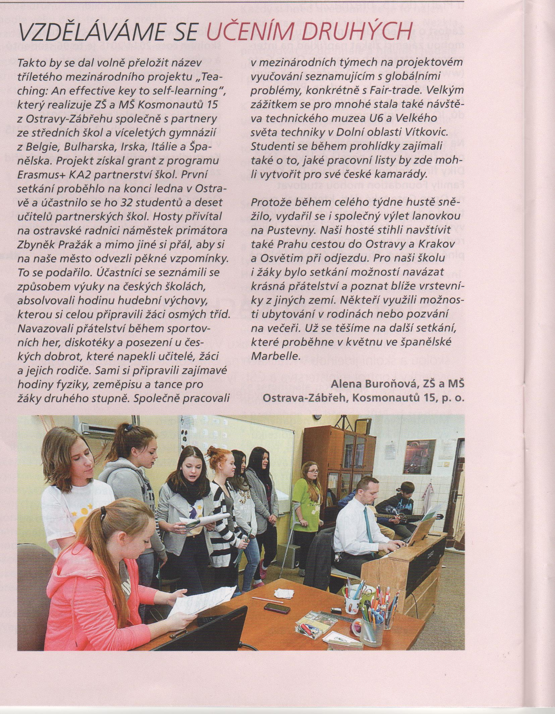
We educate ourselves by teaching the others
Thus the name of a three-year international project "Teaching: An Effective key to self-learning" could be translated into Czech. This project implements Kosmonautu 15 Primary School from Ostrava-Zábřeh, together with partners from secondary schools and grammar schools from Belgium, Bulgaria, Ireland, Italy and Spain. The project received a European Union grant for Erasmus + KA2 school partnership. The first meeting was held in late January in Ostrava, with the participation of 32 students and ten teachers from partner schools. Guests were welcomed at Ostrava City Hall by deputy mayor Mr. Pražák and among other things he wished our guests to bring good memories of our city to their homes. And it worked. Participants learnt about the way of teaching in Czech schools, attended a music lesson, which was prepared by our pupils from the eighth grade. Students made new friends during sports games, a disco and an international evening with the Czech specialties that were prepared by teachers, pupils and their parents. Our guests taught our pupils about Europe, their national Irish and Bulgarian dances, Physics and Geography, they prepared interesting lessons. Participants worked together in international teams on a project teaching about global problems, particularly Fair-trade. A great experience for many became a visit to the Technical Museum U6 and the Great World of Science technology museums in the Lower Vítkovice. Students were working on ideas for worksheets that they could create for their Czech friends visiting these museums. And because the entire week it was snowing, the successful joint cableway trip to Pustevny was held. Our guests also managed to visit Prague on arrival, and Krakow and Auschwitz on the way home. For our school and students this meeting was the possibility to establish a beautiful friendship and to get to know peers from other countries. Some Czech families took the opportunity to accommodate or to invite to dinner our guests. We are looking forward to the next meeting, which will take place in May in Marbella, Spain.

