1) Read the Czech words and guess their English meaning. Check your answers. Then write these words in your language.
a) beloved, b) evening, c) fire, d) got a fever, e) has got a headache, f) head, g) hurts, h) in the fire ring, i) is burning, j) last night, k) my, l) yesterday

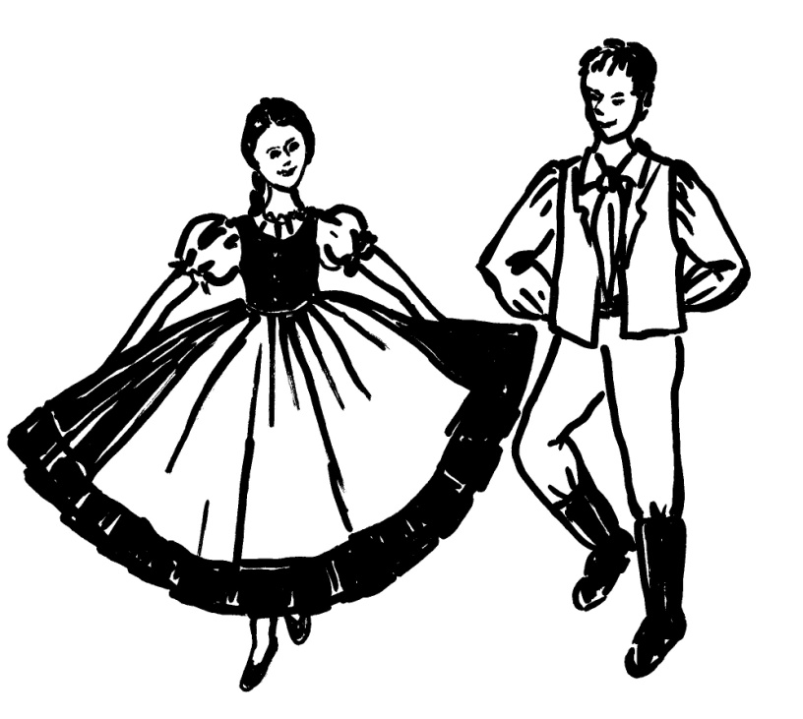

1) Na ohnišču -
2) Oheň -
3) Horí -
4) Moju -
5) Milu -
6) Hlava -
7) Bolí -
8) Hlava boli -
9) Včera -
10) Večer -
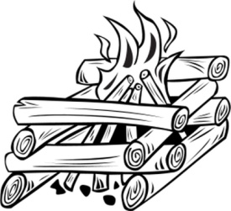
11) Včera večer -
12) Zahorela -
2) Read the English version of the song. It is not the exact translation; some words are different than in the old Czech song so that it is possible to sing it in English version too.
3) Listen to the song. Then read slowly the Czech words. Finally learn to sing and dance the song.
