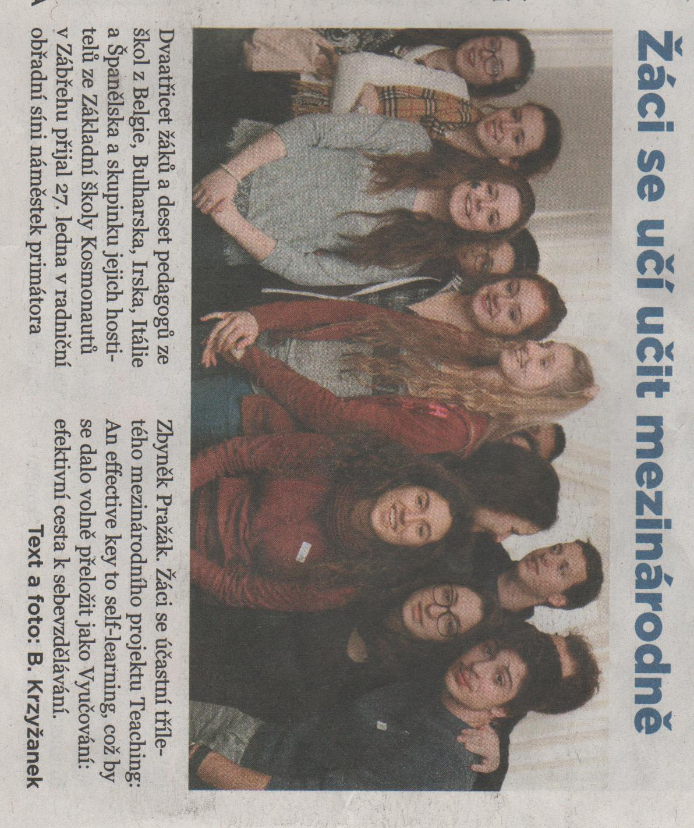
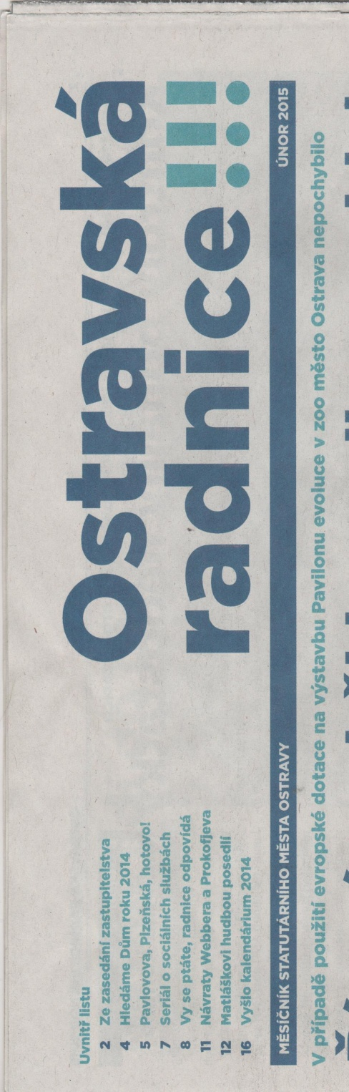

TRANSLATION:
Thirty-two pupils and ten teachers form school from Belgium, Bulgaria, Ireland, Italy, Bulgaria, and a group of their hosts from primary school Kosmonatů from Zábřeh met the deputy of Ostrava mayor Mr Zbyněk Pražák at the Ceremonial Hall of the Ostrava town-hall on 27 January. Pupils are taking part in the three-year international project Teaching: An effective key to self-learning which can be translated as “Vyučování: efektivní cesta k sebevzdělávání”.

