PLASTIK:
AUS DEM PO IN DEN BAUCH
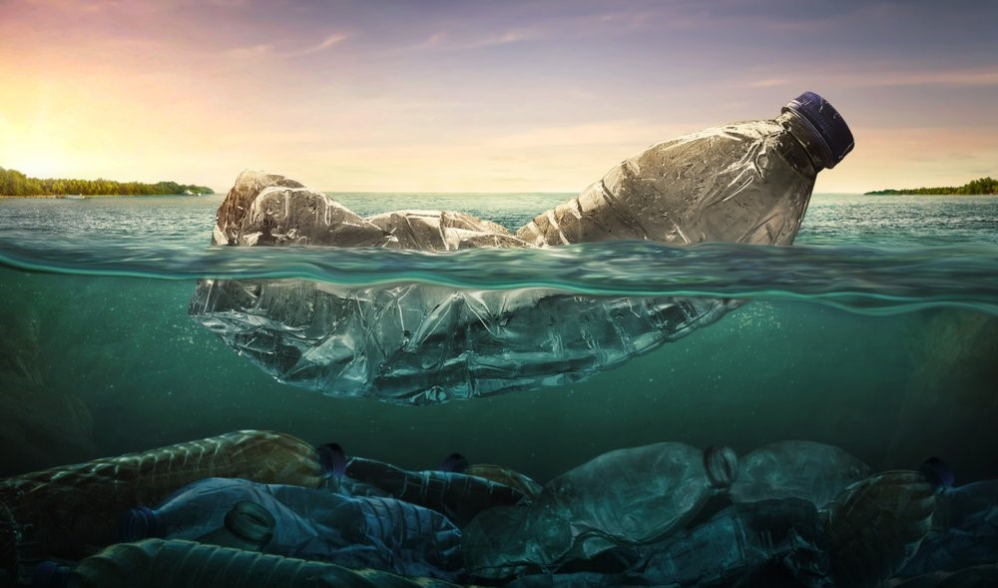
Ein Kind aus Mantua wirft eine leere Plastikflasche in die Flusse Po.

https://www.funweek.it/evolve/home/2019/06/11/plastica-in-mare-wwf-33mila-bottiglie-al-minuto-acqua/
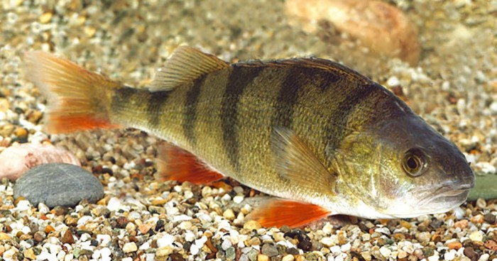
Die Flasche fährt durch das Wasser. Ein Fisch sieht sie und er frisst sie.

http://www.guidaallapesca.it/articolo/2990-persico-reale-habitat-e-descrizione/
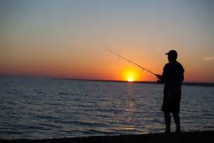
Ein Mann aus Adria geht an den Po angeln und er fängt den Fisch.

http://www.zombiestickz.com/wp-content/uploads/2016/08/Fisherman-fishing-at-sunset-1-2.jpg

Zusammen mit dem Fisch essen wir auch Plastik!

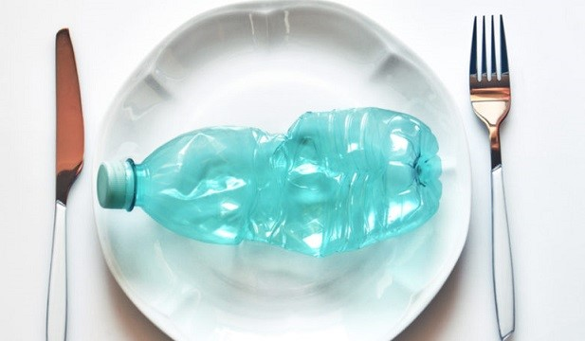

https://www.ehabitat.it/2018/07/09/microplastiche-nel-cibo/

Das ist die neue Ernährungskette!
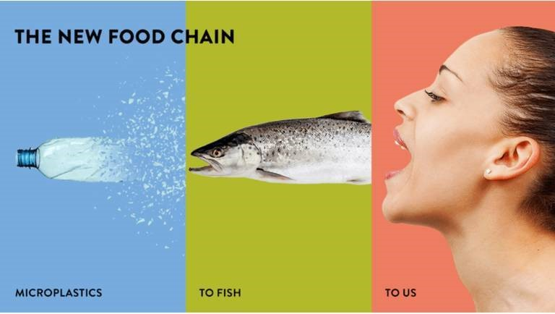

http://georgerothert.com/plastic-food-chain/

