TASKS FOR SEPTEMBER-NOVEMBER 2020
ETWINNING PROJECT: CLIMATE CHANGE IS A POLITICAL CHOICE

WEEK 28 SEP- 2 OCT

- Show Twinspace to students: https://twinspace.etwinning.net/93164/ and give each username and password. They write it down and teacher keeps the list (just in case)

- Explain homework for next week, to be done at home:
1.1.1. INTRODUCING OURSELVES:
    - Show students a few videos of students introducing themselves
Task: record a similar video in Flipgrid https://flipgrid.com/568597ef answering:

QUESTIONS MOSTLY VOTED
1-What do you like doing in your free time?
2-What kind of music do you like listening to?
3-What is your favourite subject?
4-What is your favorite sport?
5-Do you like animals? What is your favourite animal?
6-What's your dream job?
7-What is your favourite food?
8-Do you like going abroad? Which country you would like to visit?
9-Can you tell us about your school,town,city and country?

    - Procedure:
      - access flipgrid: https://flipgrid.com/568597ef
      - log in with a Gmail account (it can be callisvic.cat)
      - click on RECORD A RESPONSE to record your video (2 m 30 s long max)
      - Add effects if you wish
      - Snap a selfie before clicking on SUBMIT

- 1.1.2. INTRODUCING OUR SCHOOLS, TOWNS, REGIONS AND COUNTRIES:
  - Take a few quizzes about partners’ schools, towns… (the correct answers together with further explanations are given at the end of the quiz)
(the objective is to get students familiar with their partners’ schools, countries…

- EVALUATION: PRE-EVALUATION:
  - Click on link: TAKING ACTION ON CLIMATE CHANGE: https://www.esolcourses.com/content/topics/environment/climate-change/climate-change-listening-activities.html
  - Do tasks 1, 2 & 3.
  - If time: click on link: THE DISCUSSION ON CLIMATE CHANGE: https://esldiscussions.com/c/climate_change.html: discussion questions to be done in pairs

WEEK 5-9 OCTOBER

- Check everyone has uploaded video in 1.1.1.

- 2.4. WHAT ARE OUR POLITICIANS SAYING AND DOING ABOUT CLIMATE CHANGE?

  - Access padlets:
    - At local level: https://padlet.com/martapcallis/local_politics
    - At regional level: https://padlet.com/martapcallis/regional_politics
    - At national level: https://padlet.com/martapcallis/national_politics
  - (if it is possible to use computers, if not, for homework) Each student adds a comment on one of the posts of each country, in the three padlets.

- Start working on 2.6. EWWR INVISIBLE WASTE CAMPAIGN

  - Explain we are going to participate in this European Commission campaign: https://ewwr.eu/take-part/#thematic_focus week 21-19 Nov designing and carrying out campaigns to raise awareness, but before we need to research and learn about the topic

  - 2.6.1. WHAT IS INVISIBLE WASTE?:
    - Warm-up activity with www.quizziz.com
(teacher launches “Live Quiz” and students take quiz with their cell phone, or if set as homework: “Assign homework”): https://quizizz.com/admin/quiz/5f5741d2a6d5b9001bbbc322/what-is-invisible-waste
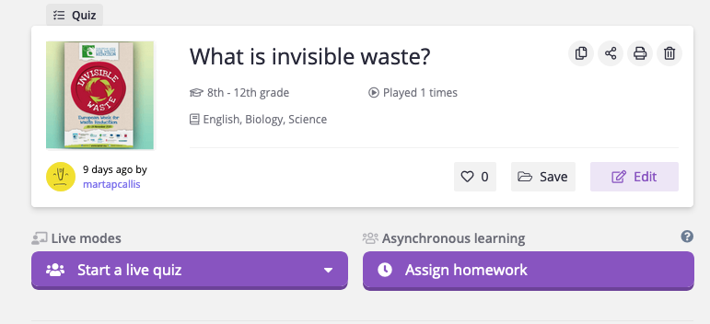
Students access the game through: www.joinmyquiz.com, and they will need a code that it will be generated when the teachers starts the quiz or assigns it as homework.

Students read articles and watch videos about Invisible waste, and then take part in the discussion forum in 2.6.1 in the twinspace:
After reading and watching the videos about invisible waste... were you aware of it before? What did you already know? What surprised you the most?

NEXT ACTIVITIES: 2.6. EWWR (= EUROPEAN WASTE WEEK REDUCTION): INVISIBLE WASTE CAMPAIGN

2.6.2. What is ugly food? And wonky fruit & vegs?

TASK 1:
- Access this noticeboard about UGLY FOOD AND WONKY FRUIT&VEGS :
- 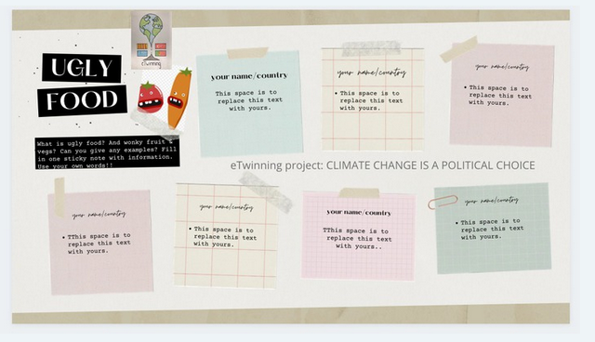
- Students should register in www.canva.com to be able to edit the noticeboard. They can use their callisvic.cat account.
Then they and edit one of the sticky notes:
- write name and country
- write information about:
- ugly food
- wonky fruit and vegetables
- about companies, shops, organizations, campaigns that are dealing with this kind of food (internationally or in your own country)
- note: there are several pages if you scroll down. The idea is “first come, first served!”, but starting editing the first page, then when it is full, the next page…
- Remind students:
    - don't erase any information provided by your partners
    - don't duplicate information, so please, read your partners' notes first
    - don't copy and paste from Internet. Use your own words

TASK 2:
- Students write in the discussion forum after reading these articles and watching these videos. Before writing, or after writing, we can hold a class discussion about the topic
Here are some articles & videos about UGLY FOOD:
  - NATIONAL GEOGRAPHIC: How ‘Ugly’ Fruits and Vegetables Can Help Solve World Hunger
  - CNN How ugly food can end hunger
  - WWF: Fight climate change by preventing food waste
  - FINANCIAL TIMES: Buying more ugly food: an imperfect waste solution?

Discuss
Please, answer these two questions with information from the sources provided and your own ideas. You can also REPLY to some of your partners' posts 1) How can ‘ugly’ fruit and vegetables help solve world hunger? 2) How do ugly food contribute to food waste and at a larger extent, to climate change?

2.6.3. Let's advocate for imperfect foods!

We need to team up students in 9 transnational groups
TASK 1: BRAINSTORMING
What kind of campaigns/actions, both in-site or online could be carried out in your schools, towns and countries? Can you think of effective measures to raise awareness of the reality of impaired fruit and vegetables and other foods? Write your ideas in the corresponding word clouds:
CATALAN STUDENTS: https://answergarden.ch/1417088

(students are only allowed to write 20 characters; don’t write full sentences!)

TASK 2: Let's work in transnational groups and create ACTION PLANS
Create groups: Catalans:
4A: 3 groups, 2 groups with 4 students, 1 group with 3 students, Group Numbers 1,2, 3
4B: 2 groups, 1 group with 4 students, 1 group with 3 students: Group numbers 4, 5
4C: 5 groups, 3 groups with 4 students, 2 groups with 3 students. Group numbers 6,7,8,9,10

Send the names to Marta Pey or edit the table in twinspace yourselves.
Choose of one the ideas of the wordclouds together with your partners in the corresponding thread in the forum, decide on YOUR ACTION PLAN! Write your email so all the members of the group can edit the presentation with GENIAL.LY or another webtool.
which campaign (name of your campaign)
- place/s (where it is going to take place)
- objectives (list of goals)
- tasks (what will be done)
- success criteria (how will you identify your success)
- time frame (by when you need to complete the tasks)
- resources (what or who can help complete the tasks)
2) Once they have agreed and completed their ACTION PLAN, prepare an attractive presentation to explain it using https://www.genial.ly/ or any other webtool. The easiest one could be GOOGLE SLIDES, but for both of them they need their partners’ emails, so they can write it in the forum (forums are always private and only visible for the participants of the project)

2.6.4. EWWR WEEK CAMPAIGNS: 21-29 Nov 2020
1) Students carry out their campaigns during this week and take pictures and videos as evidence.
They publish their presentations, pictures and videos in this page of Twinspace.

2) ONLINE WORKSHOP BY “ESPIGOLADORS”(Catalan organization) ON FOOD WASTE
- Friday, 27 November, 10.15 am CET time.

Catalan students: The three 4 ESO groups (whole class) will be in class and teacher will connect to the MEET meeting. (link will be provided):
4 ESO A: Marta Martí & Miquel Planes
4 ESO B: Gemma Bussoms & Marta Pey
4 ESO C: Bruna Portet / Oriol Chumillas

Portuguese, Turkish and Greek students are more than welcome to join as the workshop will be in English and it is intended for all students taking part in the project!

The workshop is called RISE UP FOR CLIMATE and it introduces the issue of food waste and its implications at both the social and environmental scope. The workshop prompts students to come up with ideas and find solutions in order to reduce the amount of food waste and advocate for a more sustainable resource-based culture.

Note: all schools must register their activities in: https://ewwr.eu/take-part/ (I think the deadline is at the beginning of November!)

