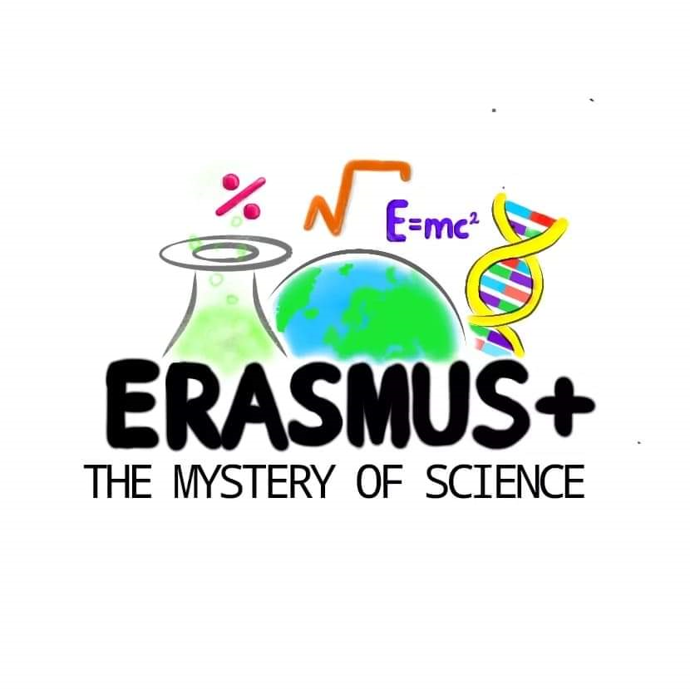
How many „words” can we make from MATH? Calculate it and then write all of them.

Ex. 3.1

