 |  |  |  |  | E | L | F
 | C | O | M | B | I | N | A | T | O | R | I | C | S
 |  |  |  | W | I | T | C | H | E | R
 |  |  | T | E | N | E | T
 |  |  |  |  |  |  | O | D | D
 |  | H | O | N | O | U | R
 |  |  |  |  |  | D | I | E
 | P | E | R | M | U | T | A | T | I | O | N | S
P | R | O | B | A | B | I | L | I | T | Y

1. Creature used in fantasy books, films and video games.
2. A branch of mathematics which is about counting.
3. Polish book you have read.
4. P(A)= $\frac{n(A)}{N(U)}$, A is…
5. 1,3,5,7… are…numbers
6. In cards: queen, king, ace, jack.
7.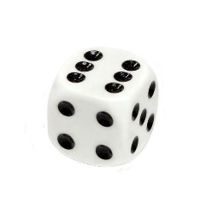
8. A way, especially one of several possible variations, in which a set or numer of things can be ordered or arranged.
9. Prawdopodobieństwo, vjerojatnost, pravděpodobnost, tõenäosus, todennäköisyys.

