License plate

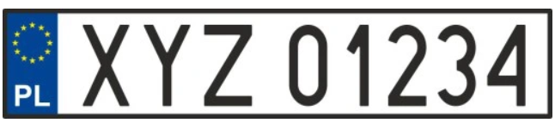

GWE K145N
- How many license plate (in Powiat Wejherowski) numbers are possible?
- How many license plate numbers are possible if they consist of:
digit letter digit letter digit ?
- How many license plate numbers are possible if no digit appears more than once?
- How many license plate numbers are possible if no digit or letter appears more than once

Ex. 6

