1. Creature used in fantasy books, films and video games.
2. A branch of mathematics which is about counting.
3. Polish book you have read.
4. P(A)= $\frac{n(A)}{N(U)}$, A is…
5. 1,3,5,7… are…numbers
6. In cards: queen, king, ace, jack.
7.
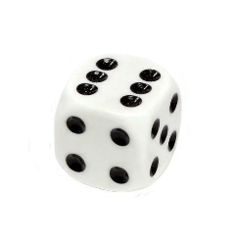
8. A way, especially one of several possible variations, in which a set or number of things can be ordered or arranged.
9. Prawdopodobieństwo, vjerojatnost, pravděpodobnost, tõenäosus, todennäköisyys.

Ex. 1

