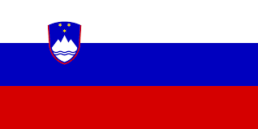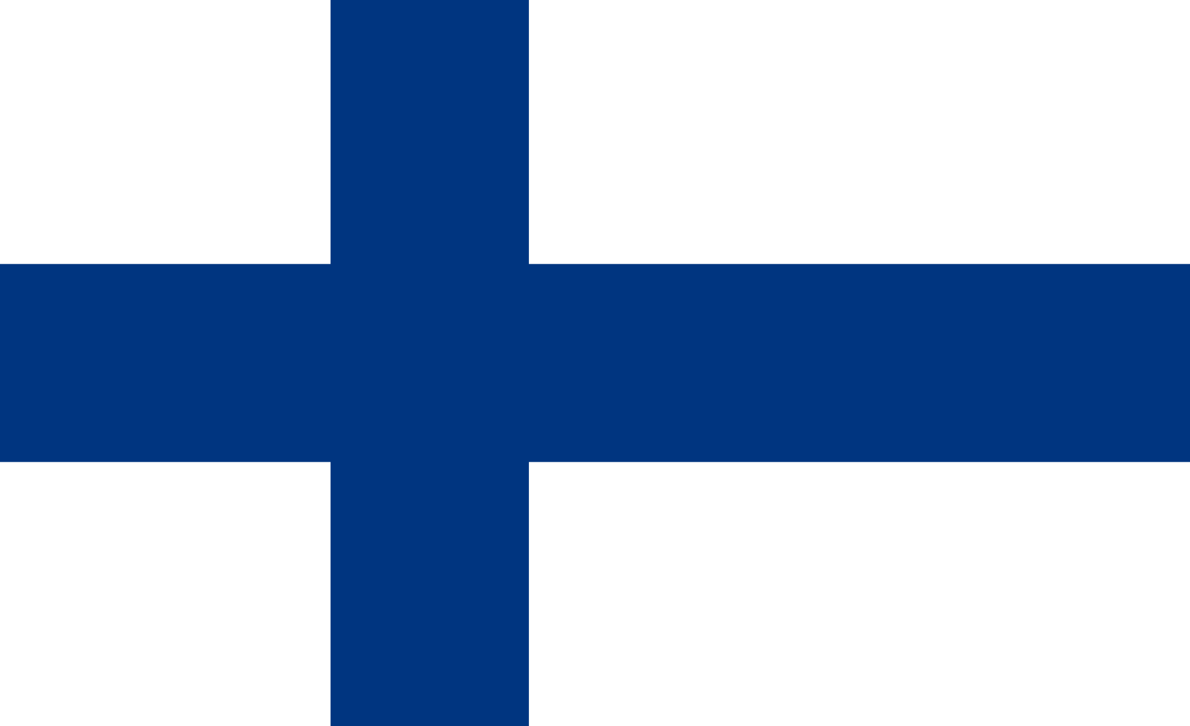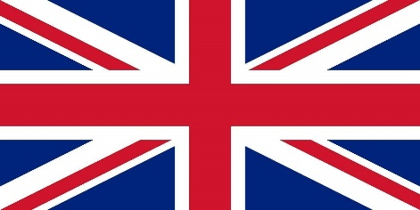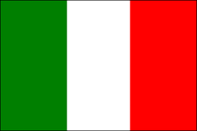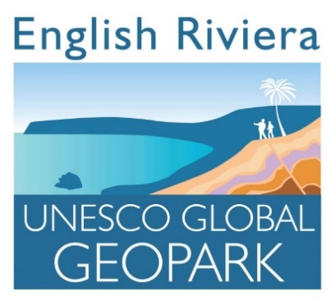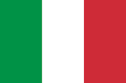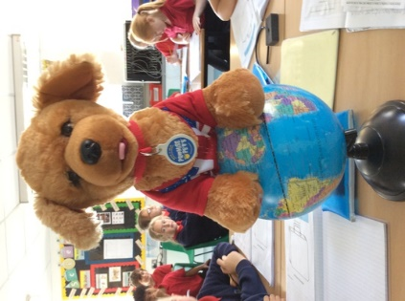

Soon, we will be working with our friends in **Finland, Slovenia and Italy** on a project about our local area and heritage.

We will be exploring **UNESCO GEOPARK** sites as well as finding out why our heritage is important.

What do you already know about this?

Please can you **complete the questionnaire** and give it to Mme.Bell or leave it in the box?

Many thanks!