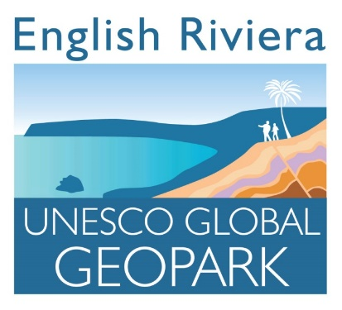
QUESTIONNAIRE
Please complete and return to Mme.Bell by Fri 18th October.

- Have you heard of UNESCO GEOPARK? YES / NO

- Can you name any Unesco Geopark sites in our local area? YES / NO

If ‘YES’, which UNESCO GEOPARK sites do you know or have visited?_______

___________________________________________________________________

- Do you know what Heritage means? YES / NO

If ‘YES’ please write here what ‘Heritage’ means to you :

Heritage is _________________________________________________

THANKYOU FOR COMPLETING THIS SURVEY

