Purisoo - Pump to Purify - Portable Purifier Water Bottle
Purify water anytime, anywhere. No contaminated water put in water bottle anymore. Manual Pump Technology. Use Purifier & Water Bottle.

https://www.kickstarter.com/projects/purisoo/purisoo-all-in-one-pumping-portable-water-purifier?lang=de
Purisoo is a reusable, portable, premium-design purification water bottle that protects you and your family from consuming contaminated water while outdoor trekking, traveling, and during disasters. With manual pumping, almost any fresh water source can be purified and filtered into clean, safe drinking water.
- Prepare for emergency situations such as typhoons, earthquakes, fire and other disasters, natural or manmade. While there may be plenty of water, it may not be drinkable. Even if not fatal, water contaminated with bacteria and/or particulates, when consumed, can make one ill. Add the included tube for hard to reach water sources.
- Even if you find a source of outdoor water – river/stream water, lake water, tap water at a camp ground – it’s not necessarily safe to drink. Contamination from wildlife, including protozoa and parasites in the water can cause sickness or incapacitation at the most inopportune time. Purisoo purifies and filters water to keep you safe.
- Travel to foreign places, especially developing countries, offers some risks when it comes to drinking the tap water. No need to take a chance. When you travel, pack a Purisoo!
- Purisoo's replaceable filters can process up to 1,000 Liters. That's the equivalent of 2,000 bottles of water - so feel free to share your purified water.
- Purisoo is part pumping technology - purify even from a shallow water source.
- Purisoo pulls contaminated water through its filter/purifier and deposits the clean/purified results into the drinking reservoir. Contaminated water never enters the clean chamber.

As an all-in-one purification/filter pump system and water bottle, Purisoo solves issues from which other portable water purifiers suffer.
- Your face does not need to be close to contaminated water.
- Does not store contaminated water.
- Has its own chamber to store purifed water.

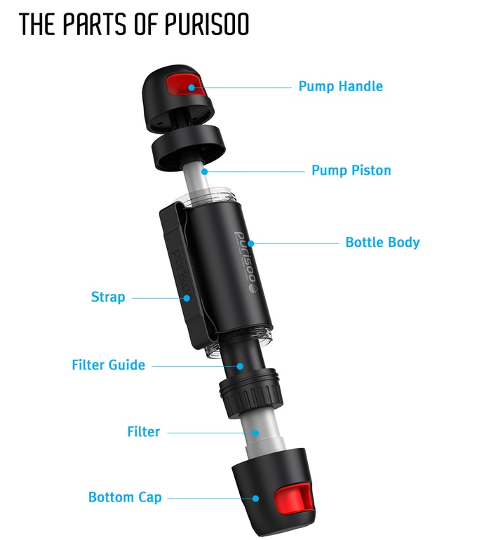
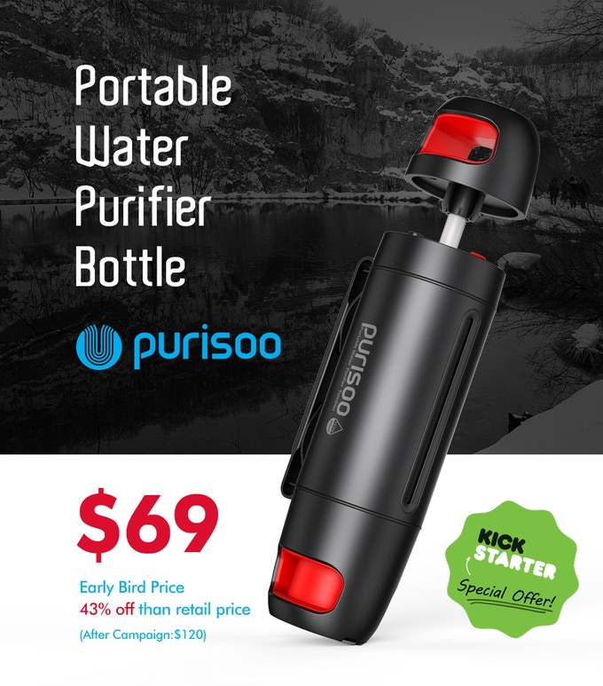
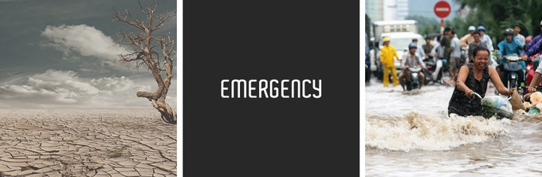
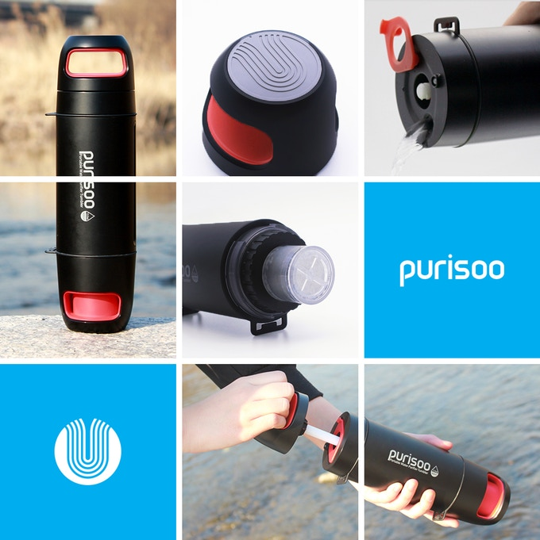

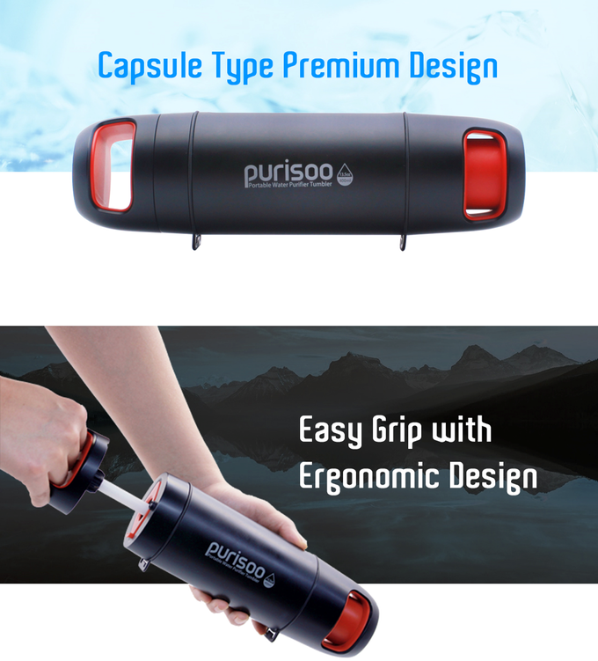

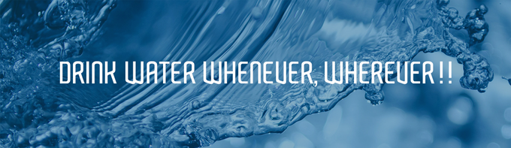
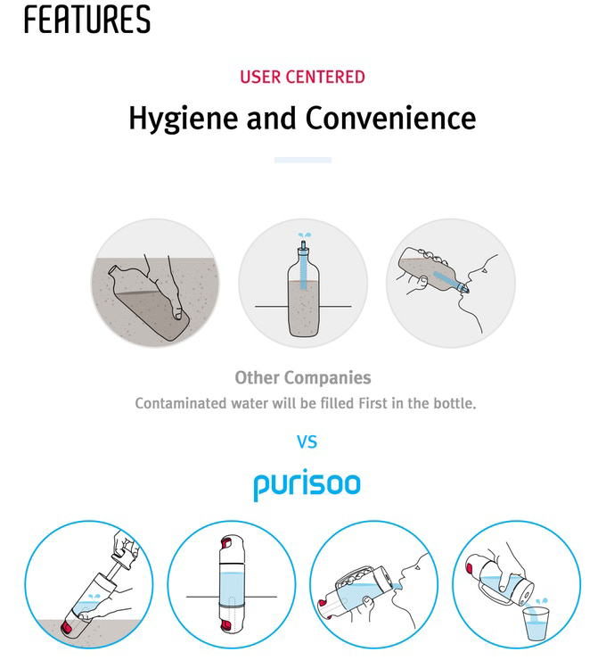
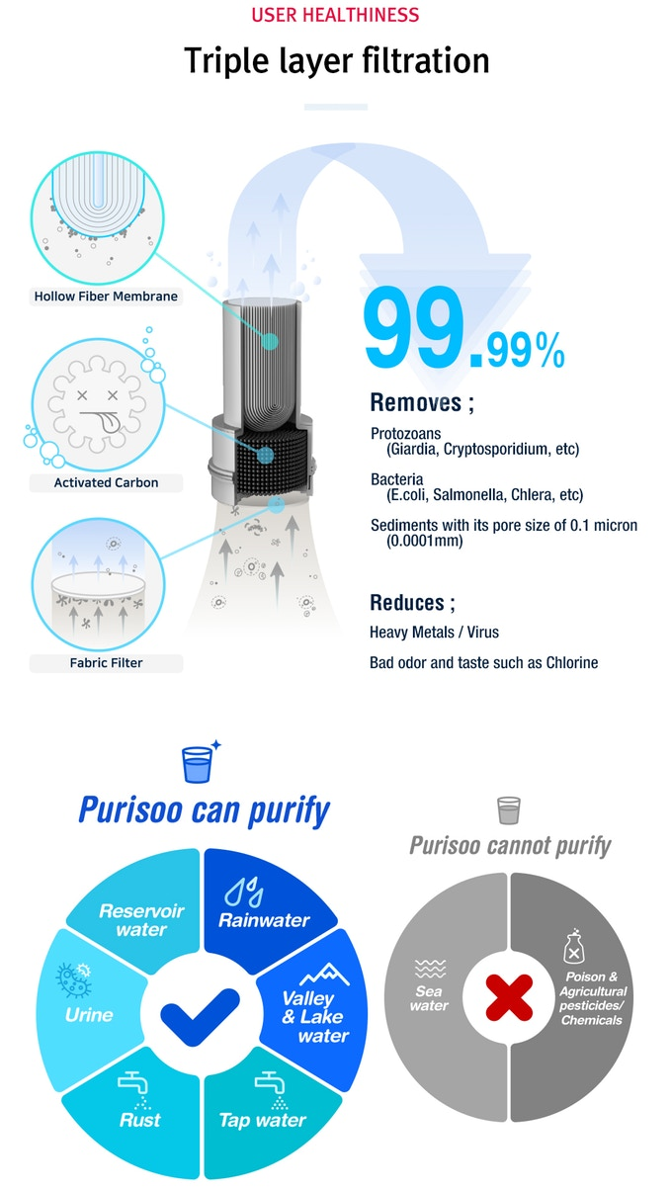
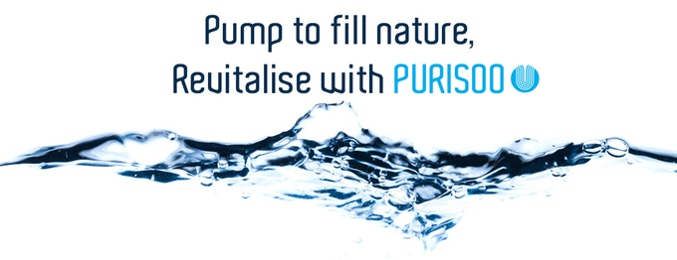
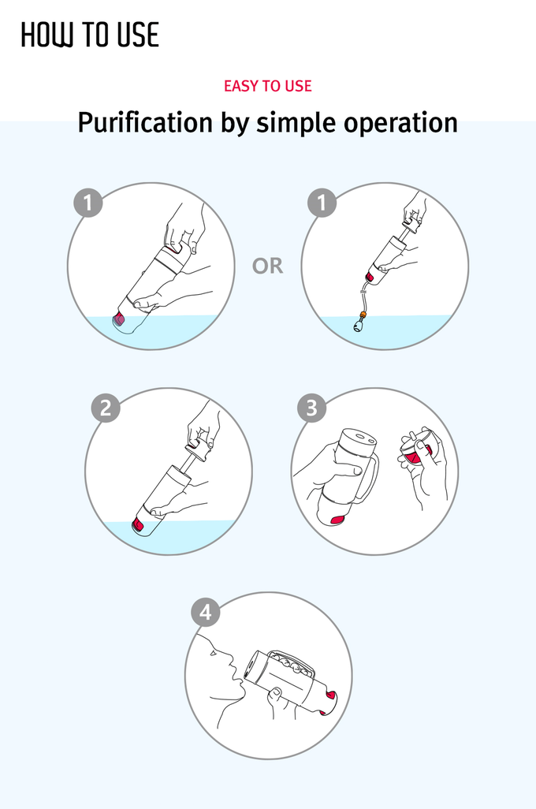
- This is a video demonstrating an earlier prototype.
