KALOYAN
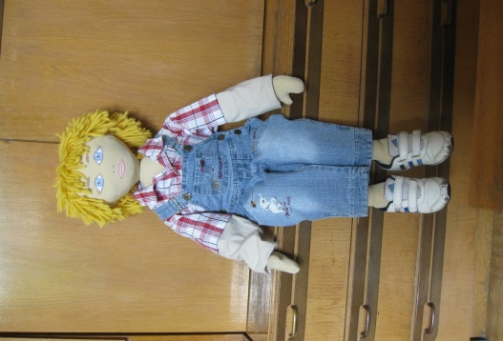
Age: 6 years
Gender: boy
Physical feature: a white skin, blue eyes, light blond hair
Family: A mother and a father - Bulgarians, a sister - 4 years
Background: The family lived in the town. Parents are highly involved in leading companies in positions of responsibility. Family honors Bulgarian traditions, lead a healthy lifestyle, do sports.
Parents often work at home, because working time is not enough. For this reason, children often take care of their grandparents. And so it gets a discrepancy in the methods of upbringing - parents declare the rights and freedoms of children, and grandparents’ restrictions and discipline.
Kaloian is receptive and inquisitive. He works with a computer, watches popular science films. He has access to large information, but it is chaotic. Kaloian gets tired and he feels tense. There are lacking control over him and his sister. He goes to bed after midnight often.

Where he lives: in an apartment, with excellent conditions, he has his own room. He does not arrange the toys and his personal belongings. The family had a housemaid.
What he likes to do at home: works on the computer and tablet, to play with a few toys at the same time. He himself has learned to read. He likes to philosophize.
Languages that he speaks: correct Bulgarian language, he now studied English diligently
What he does with ease/ dislikes: quickly makes friends, do not bother himself to make contact. Everyone and everything is interesting. He does not like to be alone.
What he cannot do / has difficulty: His attention is not sustainable, he does not listen his interlocutors to the end, he does not finish work until the end.
What makes Kaloian happy / sad / depressed: to be with his family, visiting new places. He loves to travel, and parents often take him on trips with them. He is interested in things that definitely do adults.
Kaloian wants everyone to hear his opinion and gets irritated when they do not understand him.

Fears: He asks a lot of questions because he is afraid of the unknown. He worries about events that did not concern him / eg. whether his father would succeed in time to change winter tires to summer ones /
Foods that he likes / dislikes: likes vegetables, fruits, legumes, dairy products. The mother is a vegetarian and often prepared vegetarian dishes. He dislikes meat. They did not buy sweets and he almost does not know the taste of chocolate.

