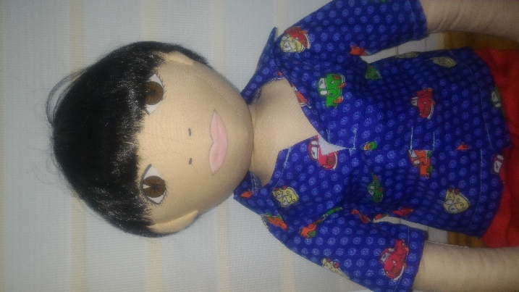
NAME: Michał
AGE: 5 years old
LANGUAGE: Polish
WHEN IS SHE CHEERFUL: He is happy when he can play with his grandparents and when he can play in the playgraund
WHEN IS SHE SAD: He is sad when he cannot go to outside.
WHAT IS SHE AFRAID: spiders
WHEN DOES SHE LIVE: Michał lives in Warszawa in block of flat on tenth floors. The flat has got two rooms. The boy has got own bedroom.
PARENTS: His mum works in the library and his dad works as engineer
WHAT DOES SHE LIKE TO DO AT HOME: He likes playing his planes, helping his mum in the kitchen, playing LEGO blocks
WHAT IS SHE GOOD AT: Micheal can fast run and ride a bike
WHAT IS DIFFICULT FOR HER: He cannot independently put clothes on
FAVOURITE FOOD: tomato soup with pasta, pizza, sandwich with cottage cheese
HATE FOOD: cucumbers, bean soup, cucumber soup
WHAT HAPPENED IN HIS LIFE: His dad lost job in residence
STORY:
Michał was born in the Poland and he lives in Warszawa with parents and his younger sister (Camilla). Michael’s dad works in Wrocław and he goes back to home only weekends. The boy goes to Kindergarten. In the Kindergarten he has got two the best friends – Martin and Clara. Michał cannot accept the rules to prevailing in the group. During lessons, he often stands, teases classmates, shouts. During fun, he takes toys and imposes his views. Michał wants to be first in all game, if he cannot be first he loud shouts, stamp his feet. He doesn’t tidy up toys and he doesn’t perform tasks on time.

What does he feel?
Can you accept this behave?
Why does he behave in this way?
Do you know similar story?What can help Michał?

