ALISA
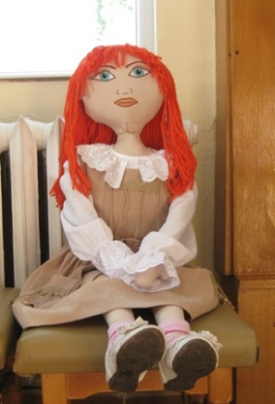
Age: 5 years
Gender: Female
Physical feature: a light skin, face covered with freckles, green eyes, red hair
Family: Mother and father - Irish, the profession of parents - programmers, Alisa has 10 years old brother. The father plays the Scottish bagpipe, and during the holidays dresses a kilt - a Scottish skirt.
Background: So far Alisa has lived in Inverness, a town in northeast Scotland. Inverness is located around the estuary of the River Ness. Here lies the large lake Loch Ness, known all over the world, with the underwater creature - the Nessie monster.
Alisa has attended kindergarten. Her beloved teacher loved to repeat: "Learn to think!“
The family moved to Bulgaria on the advice of the doctors. The air in Scotland is of increased humidity. Specialists recommend parents seek a country with a warmer and more dry climate,
because of lung problems Alisa.
She sometimes gets seizures and to ease her breathing, she uses an inhaler. She did not part with it, even when sleeping.
Alisa almost always wears sunglasses. They protect her eyes. They are very sensitive to direct sunlight and the bright rays dazzle her.
Where she lives: In the house for rent, at the foot of Ilchov Hill. She has a private room.
What she likes to do: Walk around the hill in the morning when the air is fresh; play outside; to swim in the pool of the yard. She loves parents to read her fairy tales, for magicians, for fictional beings.
Languages that she speaks: Only English. She does not understand a single Bulgarian word.
She does with ease / dislikes: She sings Irish songs with pleasure, especially when her father plays the bagpiper; she loves insects - she has a herbarium of a variety of bugs.
What she cannot do / has difficulty: When she runs away, when she is scared or anxious, she gasps.
What makes Alisa happy / sad / depressed: The noise of the sea and warm sand, the smell of pine forest. She's sad when wants to tell kids from kindergarten and ladies about her Scotland, but she can not because she can not speak Bulgarian.
Fears: Do not lose her inhaler, which in a moment of crisis helps her breathe
Foods that she likes / dislikes: Oatmeal - traditional Scottish breakfast; fried eggs; toast with sausages; tea with milk; pancakes and hagi; Scottish smoked salmon. She does not like spices in eating.

