AGE: 3
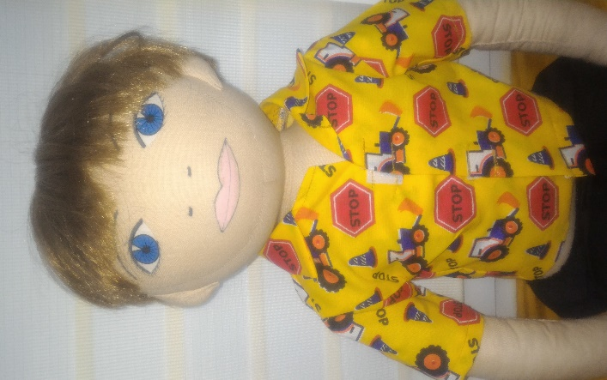
NAME: Maciek
LANGUAGE: Polish
WHEN IS HE HAPPY: When he is playing with a miniature railway and LEGOs
WHAT IS HE SAD: When he is ill
WHAT IS AFRAID OF: dogs
WHERE DOES HE LIVES: Maciek lives with his parents in a big flat in Warsaw
PARENTS: Maciek’s mom and dad have a pharmacy
WHAT DOES HE LIKE: Building with LEGOs
WHAT HE’S GOOD AT/ WHAT’S DIFFICULT FOR HIM?: He draws very nice, he doesn’t like playing with puzzles
FAVOURITE FOOD: pancakes and sandwiches
FOOD HE DOESN’T LIKE: salad, rice
HAVE HAPPEN ANYTHING IMPORTANT IN HIS LIFE? Mathew in 3 years old and he went to nurseryschool in September
STORY:
Maciek was born in Warsaw and he lives there with his parents. He just turned 3 years old and went to kindergarten for the first time. It is hard for him to part with his parents when he comes to kindergarten in the morning. He cries and doesn’t want to stay there or play with other children and teacher. He miss his parents very much and keeps asking „When I’II go home?” and „When my parents will come?”. He’s very sad and keeps crying and wal king around the calssroom with a teacher when other children play.

How’s Maciek feeling?
How can we help the boy?
What can we do to make him feel better at kindergarten?

