Name: Teresa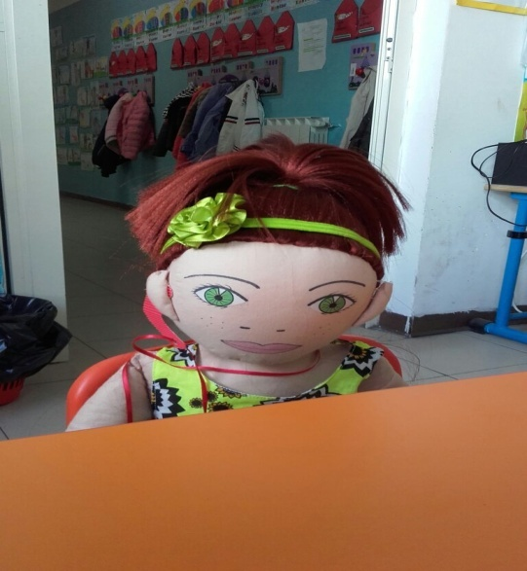
5 years
Family structure: mother, father, one brother.
Cultural background: Teresa was born in Spain. Teresa’s mother is from Italy and his father from Spain. The family lived in Spain until Teresa was two years old, where Teresa's mother worked in Hospital. At home they follow the traditions of both countries. They eat paella and lasagna and dance flamenco and tarantella.
Where she lives: Teresa lives in a rented flat in Battipaglia.
Languages she speaks: Teresa speaks Spanish very well, she does not know Italian well.
Likes, dislikes, difficulties: Teresa is very athletic. She practices rhythmic gymnastics. Teresa likes different games. She plays board games, computer games and box games. She always wants to be the first and to win. Teresa shares his toys with other children.
Teresa does not like waking up early in the morning. She does not like it when sometimes children tease her in the kindergarten. She does not like singing and learning poems, because then she has to show them in public.
Teresa finds it difficult to speak Italian
Food she likes, dislikes: Teresa likes chicken. She does not like vegetables
Fears: Teresa is afraid to be alone at home.
Physical specialties: She is deaf to one ear, because she had the measles when she was a baby
Recent history: Teresa's family moved to Italythree years ago. Teresa started to go to kindergarten and tothe gym for gymnastics. Teresa really likes living in Italy, because it Is a country like Spain. Teresa's grandmother teaches her Italian so that it can be easier for her to communicate with other children.
Teresa tells the teacher she does not hear when the children call her. She suffers because she cannot play with them.
The teacher tells children to get close to Teresa when they talk and they want to play with har to or take her hand.
Children say they understand and play with her.

