NAME : Caroline
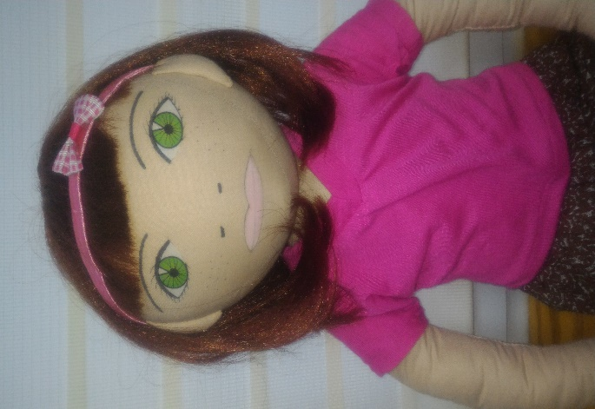
AGE: 5 years old
LANGUAGES: Polish
WHEN IS HE/SHE HAPPY: When she walks with parents, spends Holiday on the beach, meets with friends
WHEN IS HE/SHE SAD: when her sister is sick, when she hasn’t seen her grandma for long time
WHAT IS HE/SHE AFRAID OF: darkness, spiders, the barking dogs
WHERE DOEAS HE/SHE LIVE: Caroline lives blok of flat with parents and her younger sister. She shares bedroom with sister
PARENTS: Father is a teacher in High School, mother works in library
WHAT DOES SHE LIKE DO AT HOME: when she plays with dolls, watches cartoons, draws, plays with younger sister
HE/SHE IS GOOD AT: Carolina can dance very well
FAVOURITE FOOD: sorrel soup, beetroot
IMPRTANT MOMENT IN HIS/HER LIFE: Carolina moved with her parents to a new apartment, she also had to change the kindergarten.
STORY:
Karolinka moved to a new apartment in Mokotów with her parents and sister, and she also had to change the kindergarten. The girl was sad to leave her friends, but she was also glad she could meet new peers. The girl is very sociable and cheerful, likes spending time with other children. She liked her new kindergarten and she also liked her new teacher. She eagerly went to kindergarten, brought her toys she shared with others. However, when Karolinka tried to join the play, she heard from the children: "There is no place anymore", "We do not have enough toys to play with you," we have too many children. The girl stopped being so cheerful as before, stopped bringing her toys to kindergarten. She wanted to have fun together with others, but children didn’t want to invite her to play.

How does Karolinka feel?
What do you feel in this situation?
Have you ever had a similar situation in your life?
What can we do to someone doesn’t feel like Karolinka?

