ALBENA
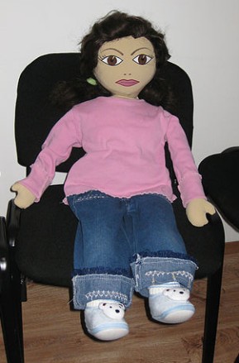
Age: 5 years
Gender: Female
Physical feature: a dark skin, dark eyes, brown hair
Family: Mother – Muslim, father - Bulgarian, no brothers and sisters
Background: The family lives in a village. For two years the father of Albena is working abroad. The mother lives in the town because there has begun work.
Albena lives in a village with his grandmother. She takes care of her. The mother visited her daughter only on Sunday when her day off. Albena is sad for her mother. In kindergarten Albena is timid and unsure of herself. She has a sense of own insignificance and inferiority. Sometimes she takes from kindergarten toys at home without permission from the teacher. She feels a strong desire for a possession - if she likes a toy, which is personally owned by another child, also carries it at home.
Where she lives: until the age of fifth year she lived with her grandmother in a village. According to the Education Act in Bulgaria at that age every child is required to attend kindergarten. So her mother takes her in the town. They live in a rented apartment in the suburbs. She has no private room.
What she likes to do at home: watching TV
Languages that she speaks: Freedom speaks Turkish. She knows few Bulgarian words.
She does with ease / dislikes: Albena is singing and dancing with pleasure. Not likes that has to sleep after lunch in kindergarten.
What she cannot do / has difficulty: She communicates with children in the group difficult because she does not know Bulgarian language.
What makes Albena happy / sad / depressed: Albena is happy when she is with her mother. She is sad every time when her mother was away from her when she was working. She is very sad for his father too. Father missing Albena very much. It is missing his jokes and games - the time when they were both only.
Fears: She's afraid to share. Strangers frighten her. She is afraid of many people who are in the same room.
Foods that she likes / dislikes: Likes milk, pasta /gyuzlemi, cakes/. Dislikes oatmeal, boiled wheat /ashure /

