Persona Dolls questionnaire for parents, spring 2018

- Evaluate your knowledge about Persona Dolls methodology.
(1 – I don’t know about it, 5 – I am very good informed)

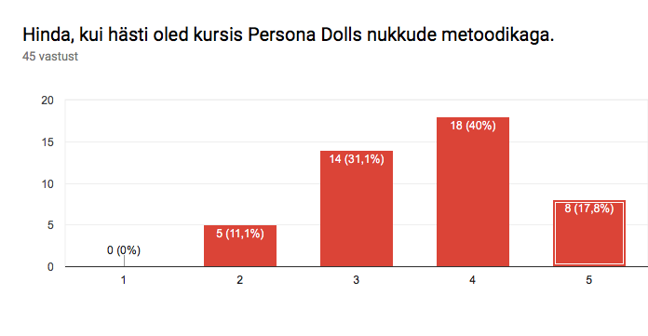

- Where have you received information about Persona Dolls methodology?

- From child
- Kindergartens webpage
- Internet
- Kindergarten
- Teacher
- Other parents
- Somewhere else (media)
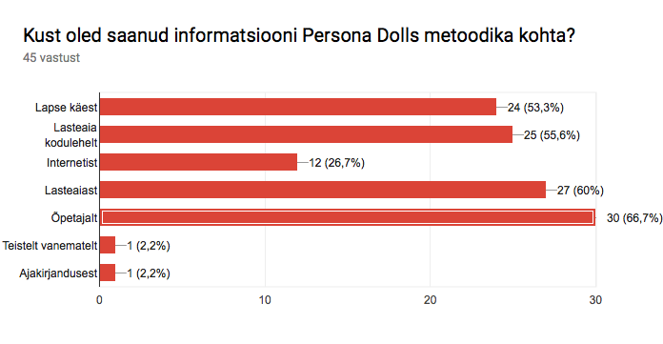
- Which of these statements you agree about Persona Dolls methodology?

- Persona Dolls methodology is beneficial for my childs development.
- I see difference in childs beahaviour and attitude.
- I don’t know enough about the methodology.
- The topics handled are important for me.

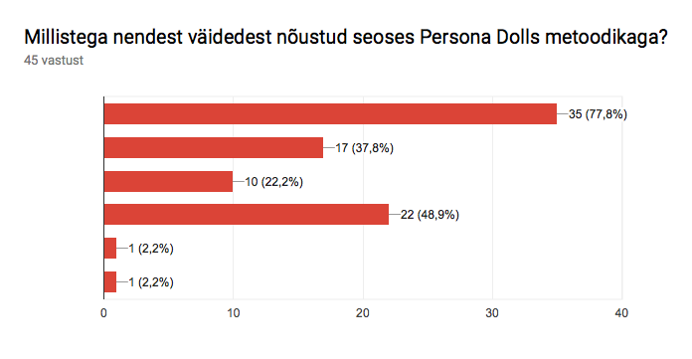

- How important it is for you that the kindergarten continues to use Persona Dolls methodology?
(1 – it is not important, 5- it is very important)

