NAME: Aneta
AGE:5 years old
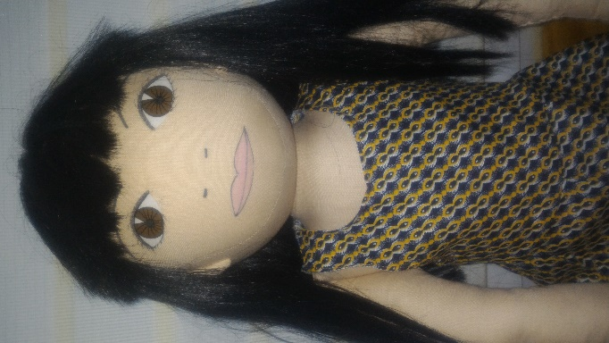
LANGUAGE:Polish
WHEN IS SHE HAPPY: She is happy when she plays with herfirends. And when her mum reads book in the evening.
WHEN IS SHE SAD: She is sad when her parents argue and when she is sick. Sie is sad when her brother is more important than Aneta for herparents- her brother needs a lot of time because he is seriously sick. She can not cope with heremotions so: to beat different children, to loud stout, she doesn’t listen adults, to throw classroom things.
WHAT IS SHE AFRAID OF:dogs, noise
WHEN DOES SHE LIVE:Aneta lives with parents and brather in the block of flat. She shares bedroom with her older brother.
PARENTS: Her dad works as bus driver. Her mum works as accountant.
WHAT DOES SHE LIKE TO DO AT HOME: She likes playing of blocks, solving tasks in the book, playing board games with parents
WHAT IS SHE GOOD AT: Aneta can make differents things with papper and she can build house for her dolls.
WHAT IS DIFFICULT FOR HER: She can not wait your turn in the game. She hates when somebody takeher toys, and when somebody doesn’t listen her commends.
FAVOURITE FOOD: pizza, pancakes, ice carems, tomato soup
HATE FOOD:Cucumber soup, dumplings with meat, pepper
STORY:
Aneta always goes to kindergarten in different mood.Sometimes she is happy but sometimes she is irritable because she doesn’t likegetting up early ( Kindergarten is far from herhome). She goes to Kindergarten by car but first sequence her mum must driver Aneta’s brothers to school. Aneta sometimes takes toys to chldren and she doesn’t want to share toys with different children. Sometimes she cannot ask other children about to borrow their toys – when children don’t agree to give toys for Aneta, she sometimes bites other children. She is nerovous when her teacher draws attention to her behavior, asks her to adjust her toys or when the teacher asks her to sit on carpet lessons. Aneta has many friends but when she behaves badly ( to beat, to bite, to take toys, to use vulgar words) chlidren don’t want to play with Aneta.
What do you think why does Aneta beat or bite other children?
What does feel Aneta when she tease other children?
What do you think, Aneta would like to have friends?
What she can do to politely play with children?
What do you think why does she stemp her legs and stout to doesn’t want to do something?
How can we help Aneta?

