Sanir 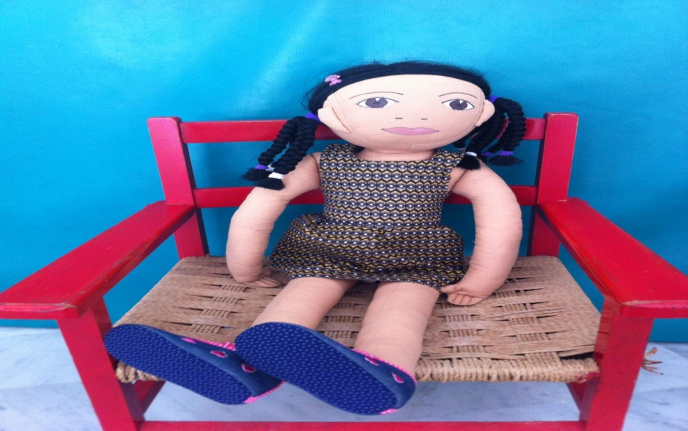
Age: 5 years
Sex: female
Physical features: dark skin, dark eyes, braids
Family:
Father - Congolese, Mother - Italian. She was born in Italy. The family has respected different cultures and traditions, depending on the origin of the parents and the place where I live. The family attaches great importance to sports, physical activity. Sanir has no brothers or sisters.
Background:
The father is an athlete who left Congo many years ago. He received an offer to play for the Battipaglia basketball team. In Italy he met his wife, who is a modern ballet dancer. When her parents are busy Sanir is left with friends and colleagues and maternal grandmother or stays in her mother's gym to play with the phone.
Problems began when Sanir had to attend kindergarten. She is always late for school because she does not like to get up early and cries every morning.
For the first time she finds herself in an environment where all children have light skin colour. She thinks everyone else considers her different from them. She has trouble in socializing because she always interacts with adults - cannot communicate freely with children and teachers. This leads to a lack of focus on stability, lack of interest in activities and various forms of cooperation.
Sanir goes to bed after midnight. There are no rules in the family, norms of behavior with which the child has to comply are not introduced.
Where she lives:
The family lives in a rented apartment provided by her father's basketball company. Sarin has her room with computer and television.
What she likes to do at home: playing electronic games, watching TV / especially sports games, music videos
Speaking languages: fluent in Italian and French.
What she likes:
any targeted physical activity attracts Sarin - she can ride and skate. She loves running. She quickly makes friends with adults. She listens to funk, rock, techno music. She dances with rhythm and pleasure.
What she finds difficult:
she does not like to work with her teammates, does not finish her homework, quickly renounces and does not end up finishing her activities. She has a corner of the classroom where she isolates.
Sarin is happy when she is in the gym or dance club. She interacts with young and emotional characters. She is interested in basketball and famous athletes. She feels important when someone refers to her as an adult.
What makes Sanir sad:
when her parents brought her to the asylum. She does not like to eat at the canteen table with all of her schoolfriends. She is continually scold and becomes aggressive breaking and throwing objects around her.
Fears:
She's afraid to stay alone. She does not want to play with other children, even when they invite her to play with them. She hates being pushed with requests and observing the rules. She loves staying in a closed room for a long time.
Likes and dislikes:
The food that she likes is pizza. She does not like pasta and vegetables.
The teacher realizes that the situation is difficult and invites Sanir's mother to come to school. They are organizing a grandfather’s day party and Sanir's mother will be the dance teacher who will teach children to dance. Sanir is happy because her mother will be in school and the children will welcome her with affection and love. After the party in kindergarten they all become happy.

