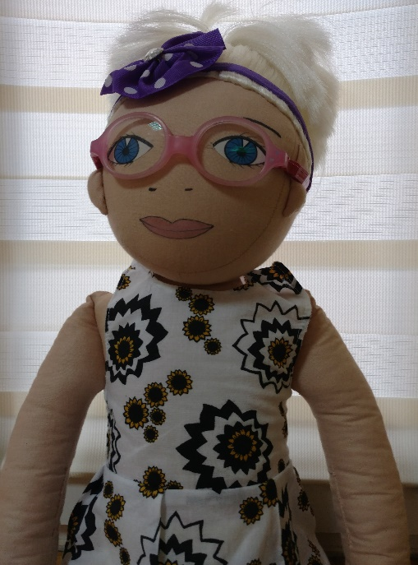
NAME: Barbara
AGE: 5 years old
LANGUAGE: Polish
WHEN IS SHE CHEERFUL: She is happy when she plays with herfriends. And when she goes to trip with her parents
WHEN IS SHE SAD: She is sad when someone is laughing at Barbara and when she is sick. She is sad when it’s raining.
WHAT IS SHE AFRAID OF: black cats, storm
WHEN DOES SHE LIVE: Barbara lives with parents in the block of flat. She has got own bedroom.
PARENTS:Her mum works in office. Her dad is a policeman
WHAT DOES SHE LIKE TO DO AT HOME: She likes playing dolls, watching a cartoon, drawing, helping her mum in the kitchen and playing with dog
WHAT IS SHE GOOD AT: Barbara cannot tie shoelaces
WHAT IS DIFFICULT FOR HER: She cannot wait your turn in the game. She hates when somebody take her toys, and when somebody doesn’t listen her commends.
FAVOURITE FOOD:ice creams, cucumber soup, pizza, spaghetti
HATE FOOD: tomato, spinach
STORY:
Barbara goes to kindergarten. She likes spending time in the Kindergarten, she likes her teacher and classmates. She has got glasses for some time. When she was an optician with her parents, the doctors said that her eyesight deteriorated and she must wear glasses. Parents told with Barbara about this situation and why to wear glasses is important. Barbara was warried her sick eyes but when she can choose pink glasses, she was happy. Girl gladly showed herself glasses her friends in the Kindergarten. One day to Kindergarten began to go new boy who laugh at Barbara’s glasses. He often teases Barbara – he pulls Barbara’s hair and takes her glasses. Barbara said her parents that she doesn’t want to go to kindergarten because there isn’t fine. She often forgets about glasses despite the she remembered what doctor and parents said (that is important).

What does she feel?
What do you feel in this situation?
Have you seen how someone laugh at different person because she/he has got glasses?
What can we help Barbara?
Why should she wear glasses?

