Name: Roberta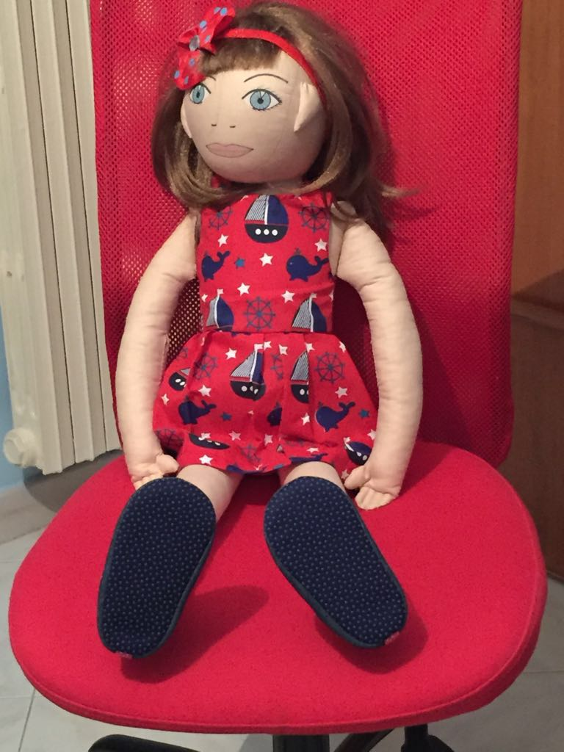
Age: 5 years old
STRUCTURE OF THE FAMILY: father, mother and a three year old sister

CULTURAL CONTEXT: Roberta lives in Battipaglia with his mother, father and sister. Roberta's father is a mathematics teacher, her mother is a lawyer, but no longer practices, her sister attends the first year of kindergarten and has a teacher just for her because she suffers from a severe form of autism. Roberta lives in a large two-story house on the outskirts of Battipaglia. On the ground floor live her grandparents, Gianni and Anna. Until a year ago she lived in Salerno, where she and her sister were born. The father was transferred to a school in Battipaglia and so the whole family decided to live in the new city.
DIFFICULTY: A little girl with relationship problems
LIKES and DISLIKES: She likes to listen to music and does not like to see people wearing shoes.
FEARS: she is afraid of loud noises and screaming people
CURRENT SITUATION: She does not have many friends because she hasrecently arrived in Battipaglia. Earlier, she lived in Salerno. Roberta suffers because in the new school children do not accept her because she almost always breaks other children’s things and is very aggressive with both the teachers and the children.
ONE DAY Roberta beging crying and tells the teacher she doesnot want to go to school because her friends do not want her in their group. The teacher calls Roberta’s parents to better understand the situation. She comes to school with his father because the mother has to look after the little sister. The father saysthat Roberta behaves in this way also in the playground, the playroom and in all places where there is aggregation of many people. Also the father explains that Roberta’s sister suffers from autism and talks about Roberta’s relationship with the little sister. Unfortunately, Roberta misses a playmate and this is because they live out of town and also because they are very busy with their second daughter. Grandparents oftentake care of Roberta. The only girl with whom she has a relationship is the little sister, who does not speak, does not accept touching her and often cries. After listening to the whole story the teacher understands the reason of the Roberta’sbehaviour and even the aggressive attitude that she shows. The teacher embraces Roberta and invites children to listen to rock music on the floor without shoes.
After a little time children are near each other, they roll on the ground hugging each other and laughing and having fun. Roberta is one of them.

After the activity the teacher ask the children some questions:

TEACHER
• Is there anyone who does not play with new children? Who is it?
• Have you ever seen similar situations?
• Is it right to reject a new person at school?
• Does anyone know other music to dance?
• What should we do to make new people feel comfortable?

CHILDREN
• The children recognize that they had had a bullying behaviour.
• Children say that Roberta is beautiful and sweet.
• The children recognize that it is not right to reject someone just because you do not know them.
• Children say that there are many games they can play with Roberta.
• Children say that they too want to be without shoes and only with socks.
• Children want to invite Roberta to their home.
• Children say that we should accept people as they are.

