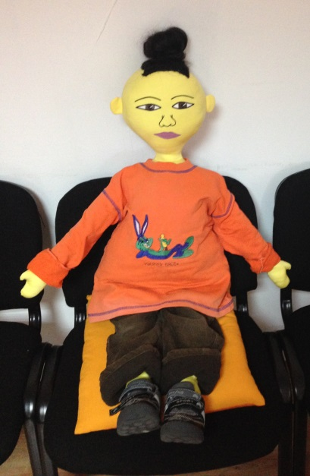
Chan Li
Age: 6 years
Gender: Male
Physical feature: a light skin, dark eyes, black hair, overweight, of short stature
Family: Mother and father - Chinese, the profession of parents – cooks. He has no brother or sister.
Background: The family is from China, Wuhan, located near the Yangzhou River. There are almost 10 million inhabitants. Here is one of the highest buildings in the world.
The family moved to Bulgaria six months ago. It came to their relatives who have a restaurant on one of the main streets. They decided to stay in Shumen and work in the restaurant.
Where he lives: The family lives in an apartment for rent on the outskirts of town. Chan Li has his own room.
What he likes to do: To talk online with his Wuhan friends
Languages that he speaks: Mother tongue - Chinese. He knows a few Bulgarian words.
He does with ease / dislikes: He is good at sums to 100 and count to 1 000 000. He is very disciplined and executive.
He does not like physical loads. He dislikes the Bulgarian cuisine. He does not eat in the kindergarten.
What he cannot do / has difficulty: He cannot participate actively in Bulgarian language classes, first: because he does not speak Bulgarian, second: because he stutters. Sports classes are a real torture for him.
What makes Li happy / sad / depressed:
He is happy when he listens to Chinese music. Every evening he visits the restaurant where his parents work. Li loves eating Chinese food in large quantities. His favorite dish is three kinds of meat with fried vegetables.
He is sad because he cannot walk around the fairy paths of Wuhan Park with the countless fireflies that provoke him to dream. He showed pictures to children. But they cannot understand him. In Shumen there is no park with fireflies.
Next year he will start attending school and will be in the 1st grade. This suppresses him - he does not speak Bulgarian, he stutters and is overweight.
Fears: He's afraid to talk to peers. He stutters and for this reason he almost does not communicate with children and teachers.
They mock at him sometimes.
Foods that he likes / dislikes: Vegetables, meat, rice, Chinese bread. Everything must be prepared in a traditional Chinese pan - a walk.
He does not like Bulgarian cuisine.

