Project „Every child is special questionnaire for teachers

- Are you satisfied with the project implemenation in kindergarten?

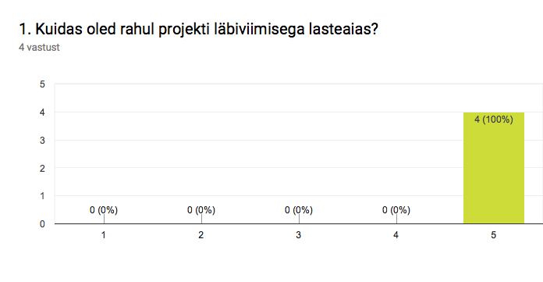
All teachers are highly satisfied.

- How do you evaluate the project impact on children

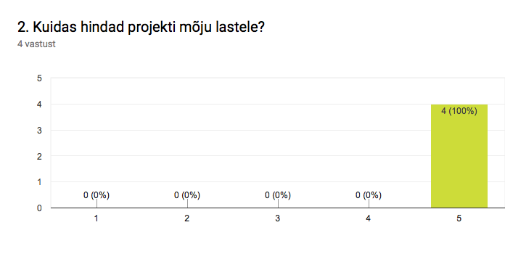
All teachers märked that children have highly benefited from the project.

- What activities were done excellent?
-activities to introduce other countries and cultures
-I am special activity
-Persona Dolls sessions with children

- Are there any activities that did not succeed?
All teachers answered no.

- Do you wish that kindergarten would take part in similar projects in the future?

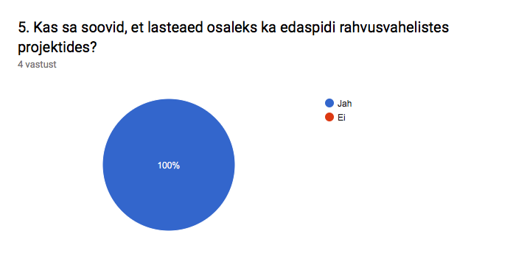
All teachers answered yes.

- What is the extra value that the project activities gave to the everyday activities?
-Persona Dolls sessions – probleem solveing with children.
-teaching values and tolerance
-Differences walls and activities
-introducing other cultures and traditions

- Do you reccomend your colleague to take part in transnational project?

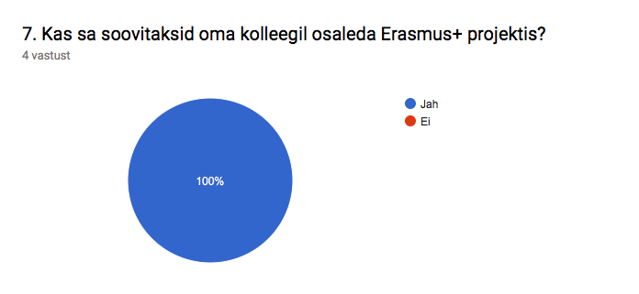
All teachers answered yes

- Why did you take part in project?

-It is important for me to handle tolerance and teach values.
-I like innovation and implement new methods with children.
-contact with other teachers in Europe.
-travelling to other countries
-new knowledges about other cultures and countries.
-improvement of english language skills.
-cooperation inside institution
-I wish to contribute to the development of the institution
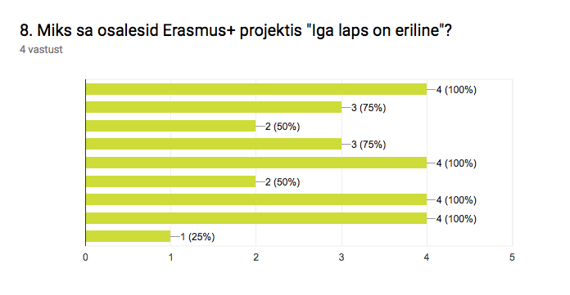
- Which of these statements are true?

-I have contributed to the success of the project
-all project activities have been conducted in the classroom.
-my knowledge about tolerance and values have improved
-my knowledge about other cultures and countries have improved
-I have successfully cooperated with colleagues
-my english language skills have improved
-participating in project has been motivating
-participating in project has developed my proffessional skills
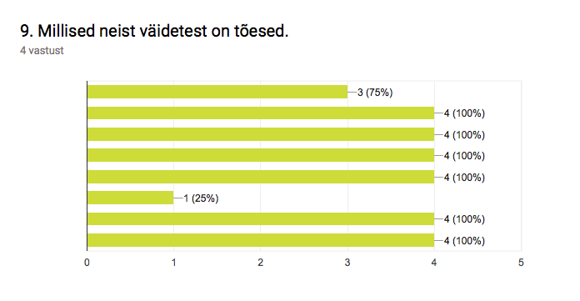
- Pick the activities you have participated

-Activities with children (good mate, i am special, differences activities)
-persona dolls methodology implementation
-differences weeks
-countries introduction weeks
-participating in seminars
-hosting partners in Tallinn seminar
-conducting questionnaires with children
-conducting materials
