K E L V I N
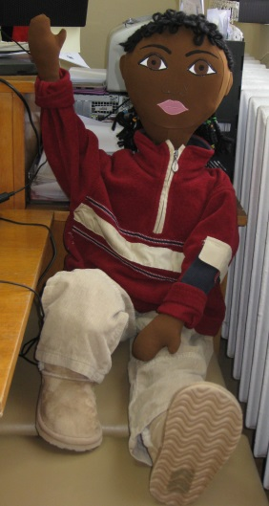
Age: 5 years
Gender: Male
Physical feature: dark skin, dark eyes, black curly hair
Family: Father – Nigerian, mother – Bulgarian. They are Christians, young people with secondary education. The family respected different cultures and traditions, depending on the origin of parents and where they live in the moment. In the family no emphasis on education in values. The family pays great importance of sport, physical activity, secular partying and good vision. Kelvin has no brothers or sisters. Parents have a marriage because they need it, not because they believe in it.
Background: The father is an athlete who left Nigeria many years ago. He received an offer to play for English basketball team. In England he met a mother who is a dancer. Their son Kelvin was born in England. When parents are busy for the child look after their friends or colleagues. Kelvin briefly attended a private kindergarten. But the service is too expensive and the parents refuse it. A year ago the father was offered a transfer in Bulgarian basketball team. The family happily moved to Bulgaria. Kelvin is at least four years. He began to study Bulgarian language of the children who play with. The mother opened a private dancing club. It became necessary child to attend kindergarten. Kelvin attends kindergarten with reluctance, he has difficulty in adapting and he is unhappy with the organization in kindergarten. He is irritated by getting up early, from the requirements in kindergarten. For the first time he falls within an environment in which absolutely all children have light skin color. He thinks all consider him different from them. He has difficulty with Bulgarian language - he can not communicate freely with the children and teachers. This leads to lack of attention stability, disinterest in activities and various forms of cooperation.
Kelvin spends his time mainly on parents workplaces - in sport halls and clubs. There he is left to the care of a random acquaintance friend - often staff member. His employment mother does not cook at home. The family ordered takeout . Or have dinner in a restaurant.
Kelvin goes to bed after midnight. There is no introduced certain rules / norms of behavior in the family with which the child to comply. The family has a liberal education - do not make adjustments to the children's actions.
Where he lives: the family lives for rent in newly built luxury studio. Kelvin has his own room, but he does not spend time in it. Young people speaking English visit their home, and Kelvin prefers their company. His older friends enjoy him and they showered him with compliments.
What he likes to do at home: playing electronic games, watching TV / mostly sports matches, music videos /.
Languages that he speaks: He fluently speaks English, speaks incorrect Bulgarian language, but understands it.
He does with ease / dislikes: Any purposeful physical activity attracts Kelvin - he rides a bike, swim. He loves to run. He quickly makes friends with adults. He listens uncharacteristic of his age music / funk, rock, techno /. He danced rhythmically and with pleasure.
What he cannot do / has difficulty: He disagrees with the regime and the guidance in kindergarten. He does not like to work independently on assigned task, he gave up quickly and does not end activities to end.
What makes Kelvin happy: Kelvin is happy when he is in the gym or dancing club, stand-alone game without parental control, planning alone games. He loves to interact with young and emotional personalities. He is interested in sports and famous athletes, to watch films in English. He feels substantial when they refer to him as an adult.
What makes Kelvin sad / depressed: when his parents took him to kindergarten when he had to comply with the discipline. Daily regime in kindergarten nervous Kelvin. He does not like to sleep at noon to eat with everyone in a certain time and why he violently expressed his dissatisfaction. Then he became aggressive - breaking and throwing objects around him. He calms hard and cries inconsolably.
Fears: He is afraid to stay alone. He worries to play with other children, even when they invited him to play with them. He hates to be pressed with demands to him and observance of rules. He does not like to stand in a closed room for a long time. Some cartoons and fairy tale characters bored him and it even scared him at times.
Foods that he likes / dislikes: He loves pizza, toast, duners, fruit, yogurt. He dislikes cooked meals, soups, creams with milk.

