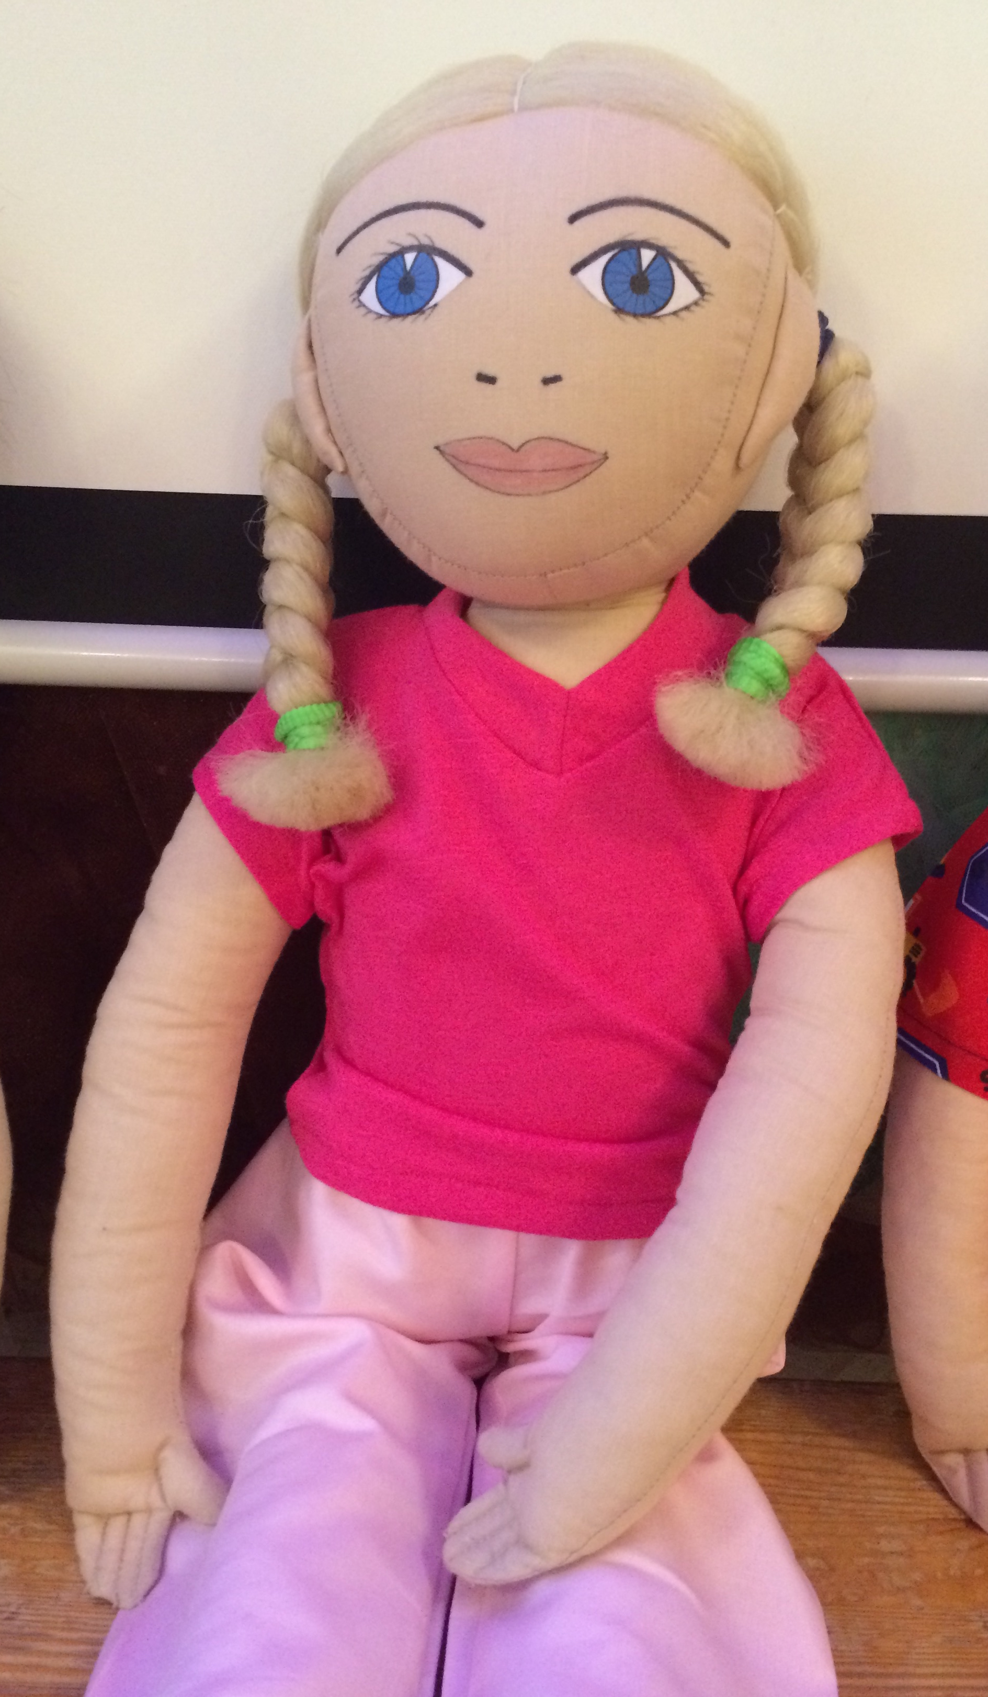
Name: Loviise
Family: Loviise lives with her grandmother and grandfather. Loviise lives with her grandparents since the age of 2. Loviise’s parents did not manage to take care of a child and therefore the granparenents are raising her. Loviise does not remember the time when she lived with her parents, she has very few memories of them.
Cultural background: Loviise is born in Estonia, she speaks estonian language and they celebrate Estonian traditions at home.
Where she lives: Loviise lives in Tallinn in Nõmme in a old private house.
Likes/dislikes/is difficult: Loviise likes different sport activities. She likes to dance. Loviise prefers to play with boys because she likes differnet running, ball and climbing games. Loviise’s favourite activity is swimming. She likes to go to swimming lessons in a big swimmingpool. She is a very good swimmer.
Loviise does not like to eat in kindergarten. She does not like the food served in kindergarten and she will be anxious when somebody asks her to try new food. Loviise does not like when other children point their fingers to her and say with loud voice that Loviise is not eating anything. Loviise usually eats in kindergarten only bread, rice and drinks water. Loviise does not like to draw because she thinks that it is boring. She would rather run outside or play ball.
Food she likes, dislikes: Loviise eats only pancakes, dumplings, rice, ryebread, white bread and fishfingers. All other food Loviise refuses to try.
Fears: Loviise is afraid that she will be forces to eat. If Loviise tryes a food that she does not like then she will get sick in stomach.
Physical peculiarity: Loviise is very active and athletic. She is very thin and has very light skin.
Recent history: Recently something serious happened with Loviise in the swimming pool. She had not eaten almost anything for a whole day and when she went swimming in the pool she felt very bad: she was dizzy and weak. Grandmother is now very worried about her health. They are visiting psychologist to get some help. Grandmother wishes that Loviise would start to eat more new things that her eating habits would be more healthy and versatile.
Loviise now has a lunch box with her every day in kindergarten so she would not feel sick again because of not been eating the whole day.

