Persona Dolls questionnaire for teachers, spring 2018
Questionnaire was conducted with 5 teachers.

- What have you changed in your teaching methods after PDM?
- The skills how to solve problems in the classroom have improved. I turn great importance to children politeness and behavior.
- I have visited other teachers activities and I have improved the content of my activities after that. I try to engourage children to talk and discuss more.
- It is important for me to teach values to children, so they would be more tolerant towards differences and they have the skills to behave correctly when different problem occure.
- I use the methodology principles of PDM when solveing the everyday problems we have in the classroom daily.
- I turn more importance to children individuality, I rehearse with children from the very early age the skills to listen others and the engouarge to speak. Children opinions are very important and all children problems need to have attention.

- What kind of changes you see in children beahviour?

- Children feel more empathy, they notice when someone needs help, they are honest, they comfort eachother, they feel happy about ecahothers achievements, they are more friendly with eachother.
- Children have more knowledge about people differences. Children have not made fun about the dolls they have been sincere when welcoming the dolls.
- Children are more aware about people differences and they are more tolerant.
Children can stand up for themselves, ask for help, and also they demand good behavior from others.
- Children are more open minded, children relationships between eachother are better, children can make the difference between good and bad behavior better, and they also notice the behavior of others. Children notice others more and wish to comfort others.

- What kind of new skills children have gained?

- Agreements about children behavior, noticing someone who needs help, supporting eachother, children understand and accept people differences.
- Ability to notice differences. Ability to discuss. Know how to act in certain situations – what to say, do or how to act.
- That we are all different and we have different ways to understand things and different ways to act.
- Children can solve problems better, they know how to justify their wishes and opinions, they know how to managa with eachother better.

- What kind of differences have you noticed in teachers behaviour, mark these arguments you agree with?

- Tachers give a positive example to children with their behaviour.
- Teachers are more tolerant towards children.
- Teachers can notice children problems better.
- Teachers are more open minded.
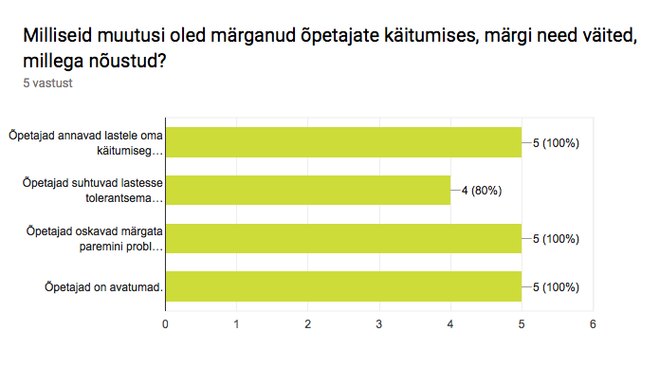

- What has been children reaction towards dolls, mark these arguments you agree with?

- Children are exited about the dolls visit.
- Children are active during the doll sessions.
- Children accept the dolls.
- Children feel empathy towards dolls and want to help the dolls.
- Children feel negatiive towards dolls
- Somethhing else to add....

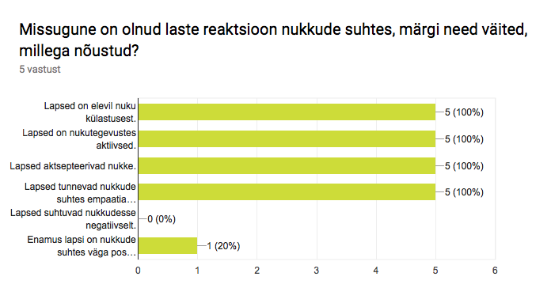
- What has been children reaction towards doll stories, mark these arguments you agree with?

- Children regognize themselves or stories what have happened to them in the dolls stories.
- Children feel empathy.
- Children want to help the dolls and to solve the problem heard in the story.
- Children are not interested about the doll stories.
- Children feel sadness.
- Children don’t believe the stories or they are not taking them seriously.
- Something else .......

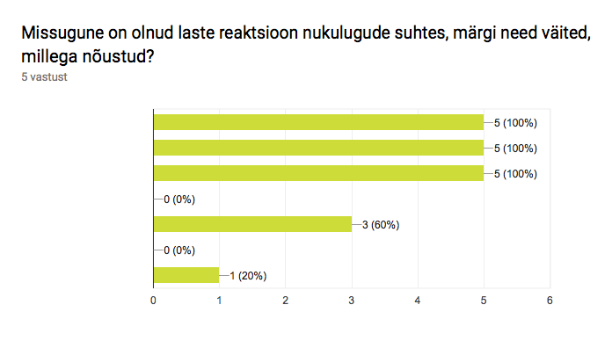
- Which of these statements are correct?

- PDM activities help children to express their feelings.
- PDM activities help children to understand their emotions.
- Through PDM it is possible to handle problems what have actially happened with children.

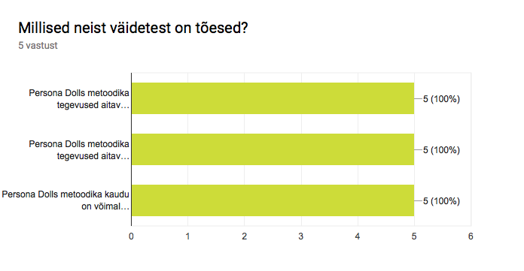
- Has teaching values became a priority in your classroom?

Blue: yes
Red: no
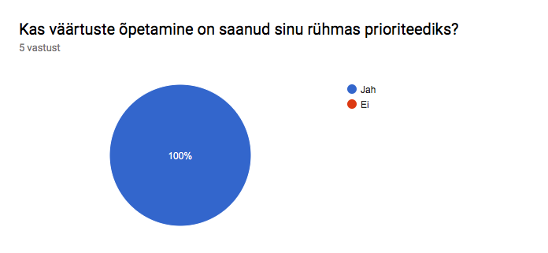
- Which kind of difficulties have you faced when using PDM?

- There has not been any difficulties.
- When there are toomany children, then all children could not have opportunity to speak.
- There has not been any.
- When there is avery difficult problem in classroom and we need to handle it at the same moment. Children see themselves in the stories or they start to blame eachother.
- There has not been any difficulties, everything is positive and motivating.

- Does the parents in your group support using PDM?

Blue: yes
Red: no
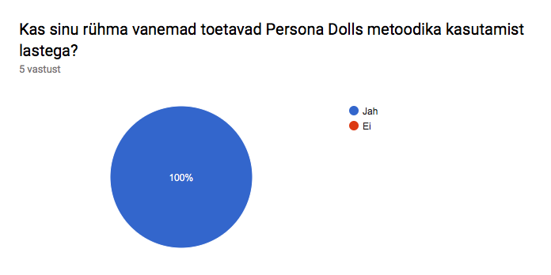

- What are the main problems you have solved in your group with PDM?

- Considering eacother, envy, dealing with loseing or failure, helping eachother, different family models, parents divorseor split.
- Exlusion from game, sharing toys.
- Bad words, bullying, exlusion from game, courage, feeling safe, helpfulness.
- Lying, being honest, talking with mouth not with hands, noticing differences and accepting them, careing and noticing someone who needs help.
- Relationships between children, including others to game, bad words, comforting eachother, noticing, sharing toys, friendship overall.

