TALATPAŞA ORTAOKULU

EVERY CHILD IS SPECIAL

DOLL BOOK
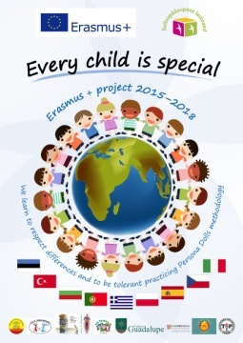

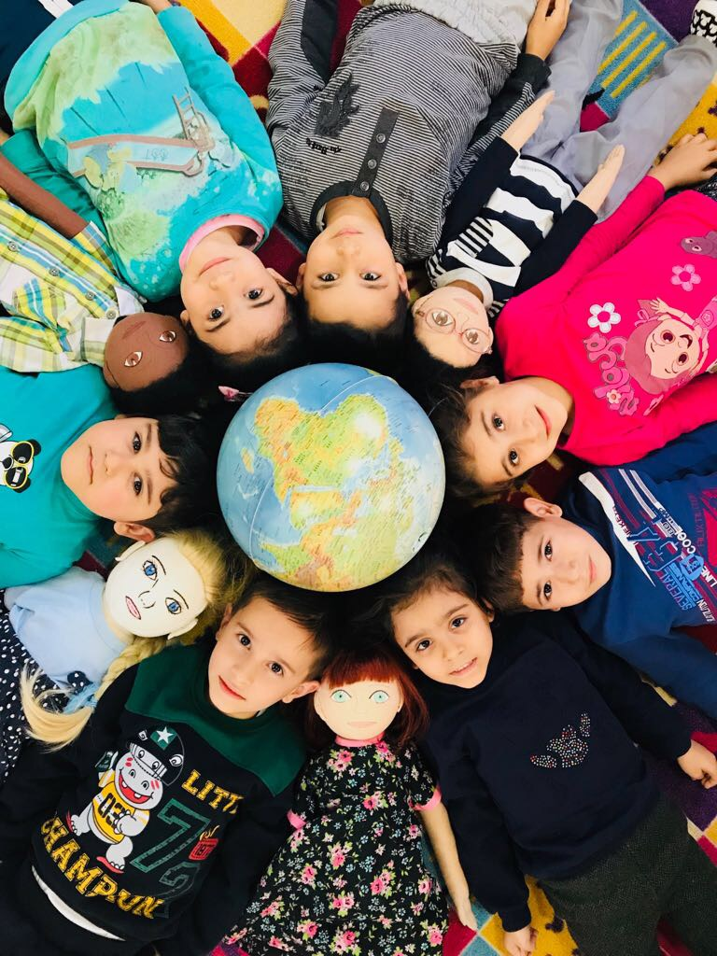

DOLL PROFILE 2
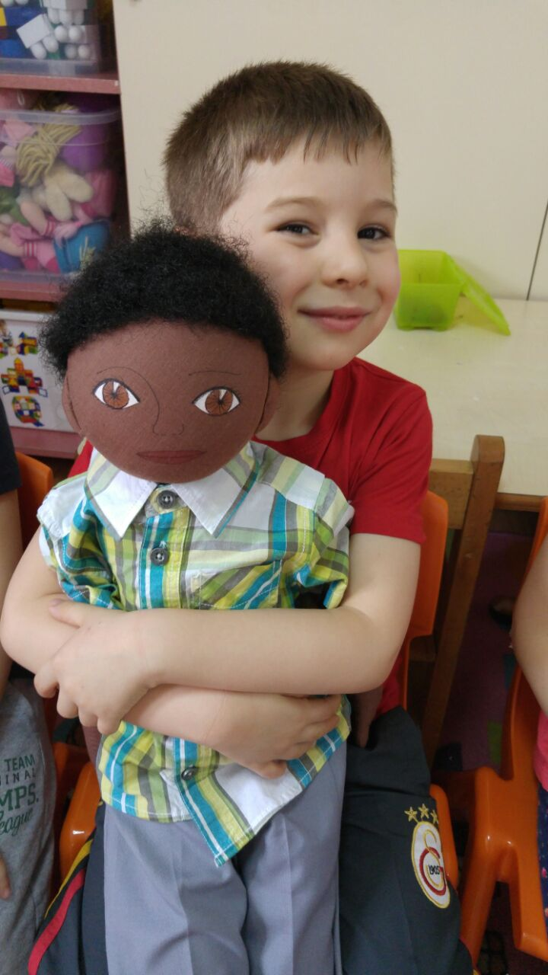

NAME : SUPHI
NATIONAL INFO : Half Persian and half Turkish
FAMILY :
His mother is persian, his father is turkish. He has an older brother, two older sister and younger sister. He lives in suburb of Izmir. He speaks Persian language very well but can’t speak Turkish.

THINGS HE LIKES :
- Playing toy cars.
- Playing lego.
- He likes Persian food.

THINGS HE DOES NOT LIKE :
- Playing group games.
- Asking questions by his teacher.
- Doesn’t like girls. Because they tease him for skin colour.
- He doesn’t like eating fish and vegetables.
DIFFICULT TO DO :
- He can’t speak Turkish, that’s why he doesn’t like being group activities.
- He can’t join his friends on games.
- He misses Iran and where he lived.
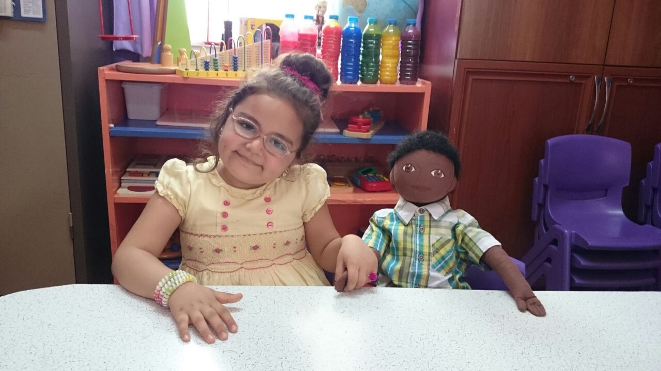
- He loves Iran more than Turkey and Izmir because he has friends and grandparents, people related him

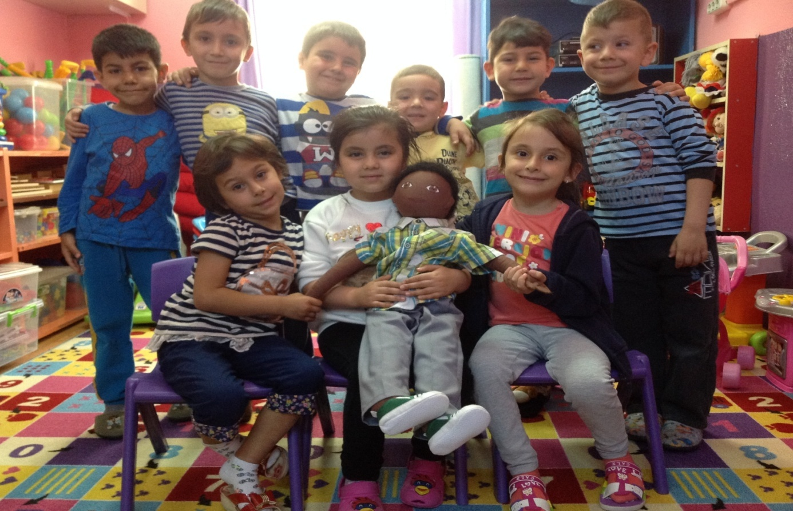
HIS RECENT STORY :
He and his family used to live in Iran. They came to Izmir because of his father’s job. His father works construction firm. They have economic problems as a family. So they have to live in suburb. He doesn’t feel well in our kindergarten , because he can’t speak Turkish fluently.

