Summary from Bulgaria
Kindergarten "Zvanche" was founded in 1934. The pedagogues working in the past and today are highly qualified, constantly seeking appropriate educational technologies, innovative techniques and maximum productive projects.
In 1994 by the Ministry of Education was approved program for the author's academic kindergarten called "I Change the World". Kindergarten "Zvanche" is one of the first educational institutions, in which the "I Change the World" program applies. The model of Author's academic kindergarten "gives" high and good groundedly self-confidence of the child, a conscious place in the surrounding world, the conscious significance of my own I. Despite this, over the last 24 years, there has been aggression at the earliest age, intolerance and insufficient adaptability in some children. Investigation of the composition of the children, the peculiarities of families, from which they come to kindergarten, ethnic and social distinctive features, etc., requires adaptation of the programming system. In favor of pedagogical and psychological searches of specialists the "Persona Dolls" methodology appeared.
The Persona Dolls methodology has been a natural extension of our programming system, as both "preach" tolerance, empathy, cooperation, partnership not only during the children's stay in kindergarten but also in their social environment outside the educational institution.
Through the methodology and the dolls we introduced into the groups, a number of problems have been addressed and solved successfully, such as:
- Aggressive manifestations based on inability to control their own emotions, hyperactivity;
- Lack of empathy for children with visual problems;
- Lack of empathy for children with speech problems;
- Lack of tolerance towards children who do not speak Bulgarian;
- Appearance of strong egoism difficult corresponding in the community of children;
- exclusion from play
- children's fears
- awareness of people with different skin color and communication with them
- awareness of people with special needs and communication with them
- awareness for people with physical differences and communication with them
- awareness of different nations and cultures and communication with them
- support and communication with children with special educational needs - autism, atypical autism, hydrocephalus, child cerebral palsy, medical problem related to growth hormone; spoken deficit; children with delayed development.
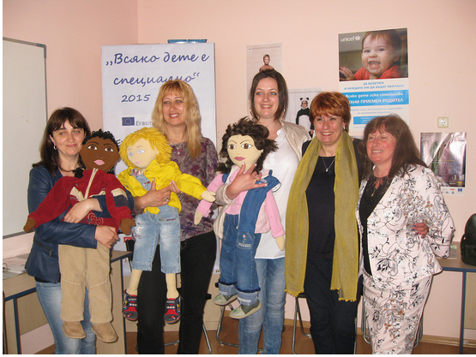
Kindergarten “Zvanche” accepted as its mission to disseminate the methodology. Considering its high efficiency, we presented it to teachers from Shumen and kindergartens in Shumen region. We presented to parents Persona Dolls and they are enthusiastically involved in our work. We presented it by organizing National training for teachers of the author's and innovative kindergartens in Bulgaria. Through broadcasts and interviews on local television and radio we have made it known to the general public in the region. We have published materials for presenting the methodology in the European annual online edition of the eTwinning CSS - Visibility of eTwinning Projects. We presented the methodology to the students from Shumen University. We presented the methodology to the students from the Medical College, whose specialties include nurses with a child profile who are preparing to work in nurseries and kindergartens. We created author eTwinning projects by training colleagues from different towns in Bulgaria, who made dolls and are applying the methodology in their kindergartens. We hope the methodology spreads to every kindergarten in Bulgaria.
National training for Bulgarian teachers
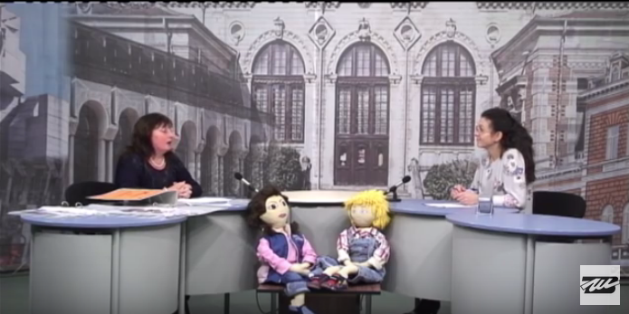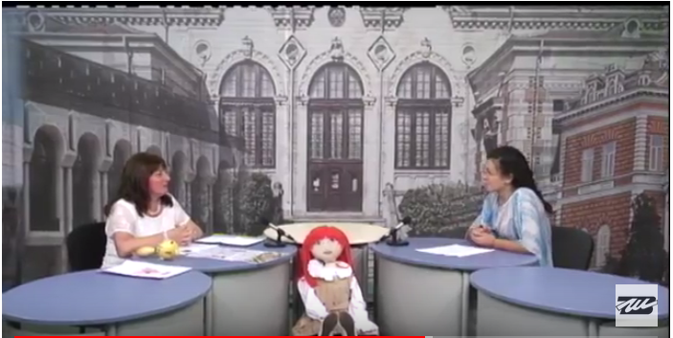
Interviews on local television

