TALATPAŞA ORTAOKULU

EVERY CHILD IS SPECIAL

DOLL BOOK

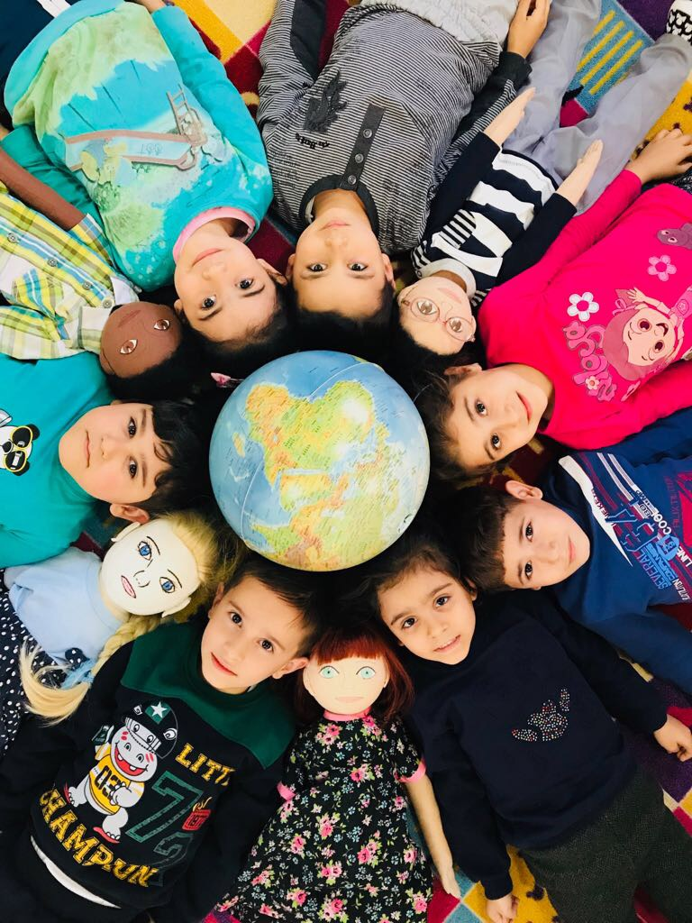

DOLL PROFILE 4
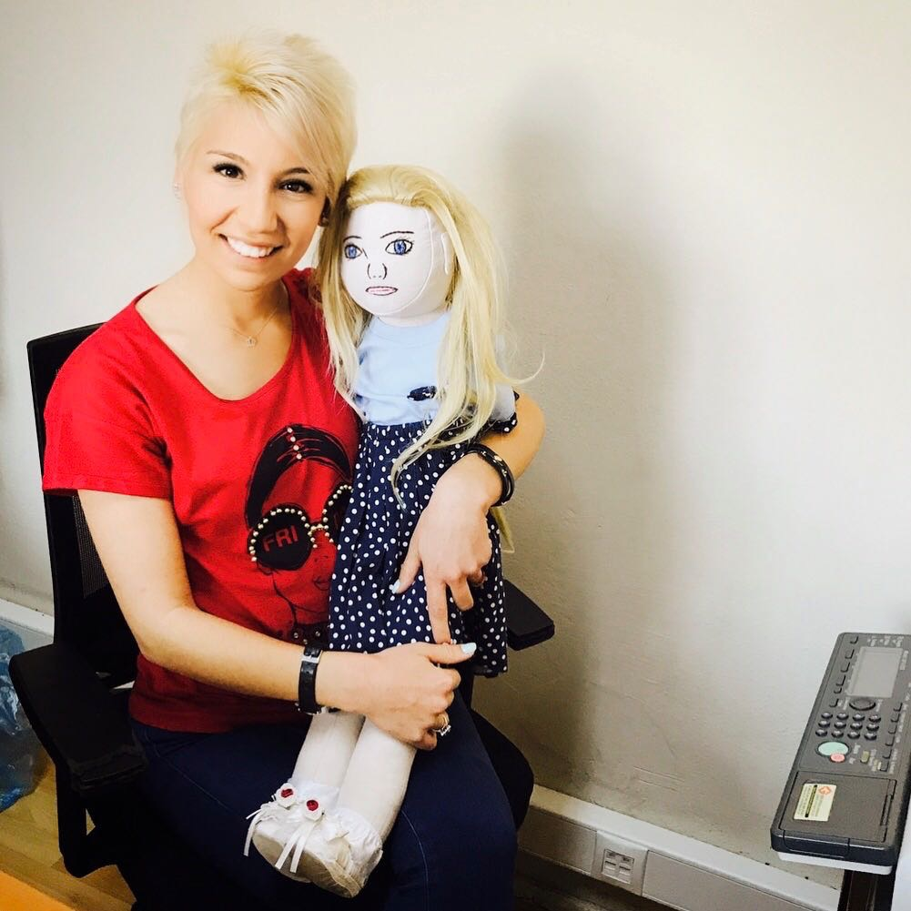
NAME : ESMA
FAMILY :
HER FATHER IS OFFICE WORKER
HER MOTHER IS HOUSEWIFE

THINGS HE LIKES :
- SHE LOVES NUMBERS
- PLAYING PUZZLE
- WATCHING WASH MACHINE WHEN IT WORKS
- SHE LIKES REPETITIVE THINGS
- SHE LOVES MUSIC

THINGS HE DOESN’T LIKE :
- PLAYING GROUP GAMES.
- CONTACT OTHER PEOPLE.
- SHE IS NOT INTERESTED HER ENVIRONMENT
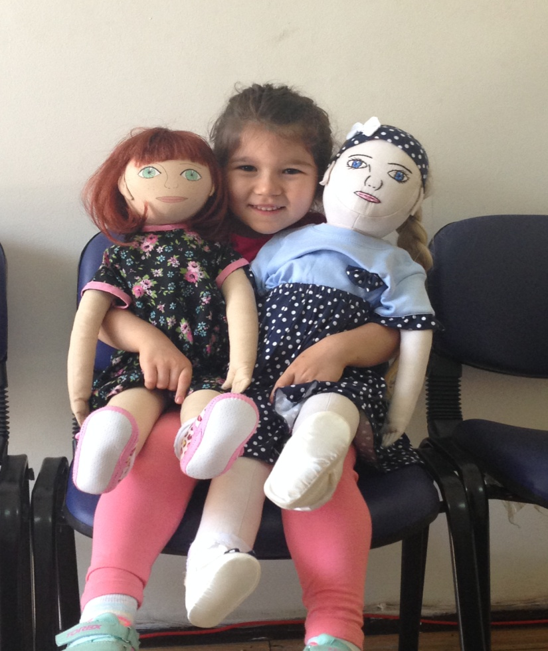
DIFFICULT TO DO FOR HIM :
- SHE IS AUTISTIC.
- SHE CAN’T JOIN HIS FRIENDS ON GAMES.
- SHE HAS SOCIAL PROBLEMS.
- SHE SCREAMS SOMETIMES.
- SHE GETS AGRESSIVE WHEN SHE METS PEOPLE WHO SHE DOESN’T KNOW.
- SHE HAS CONTACT JUST HER TEACHER IN CLASS.

RECENT STORY :
- HER FAMILY REALIZED HER DIFFERENCIES WHEN SHE WAS 2 YEARS OLD.
- THEY WENT TO CHILDREN DOCTOR. THEY LEARNED THAT SHE IS AUTISTIC.
- SHE BEGAN TO GO TO REHABILITATION.
- SHE HAD MANY MANY PROBLEM WHEN SHE STARTED TO COME TO OUR KINDERGARTEN.
- HER TEACHER AND HER FAMILY ALWAYS KEEP IN TOUCH FOR SOLVE HER PROBLEM.
