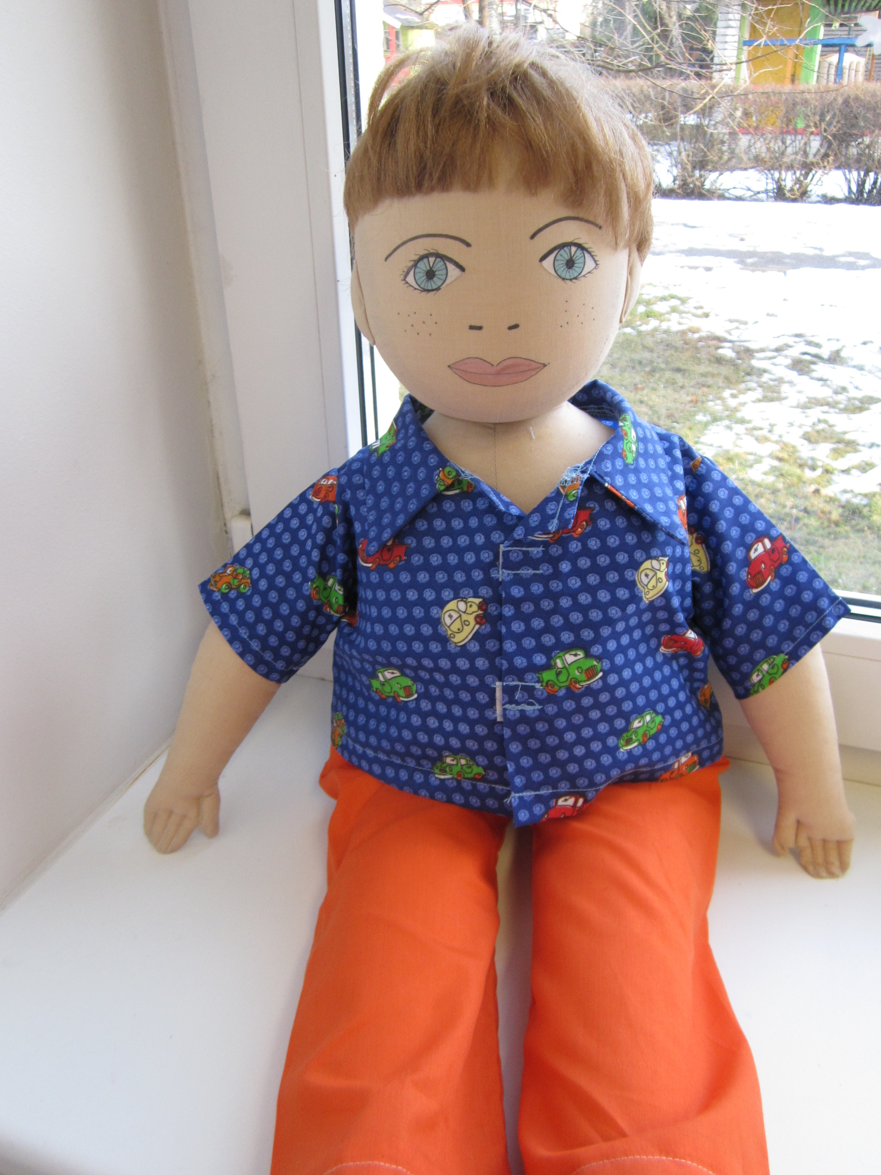
Name: Peeter
Family: Peeter lives together with his mother and father. He is the only child in the family.
Cultural background: Peeter was born in Estonia, his mother and father are Estonian. Peeter speaks Estonian, but knows a few words in English, which he has learned from the internet (youtube).
Where he lives: Peeter lives in the center of Tallinn, in a neighborhood with private houses. Peeter lives in a semi-detached house. He has a neighbor who is one year younger than him.

Likes/didlikes /is difficult: Peeter likes to play on his Ipad. He knows how to search for and play videos on Youtube. Peeter is very interested in playing computer games.
Peeter doesn´t like sports and he hates playing outside. He finds it difficult to imagine himself doing outdoor activities. Peeter doesn’t find any activities in kindergarten that he likes, and he wants to take his telephone with him to kindergarten to play with.
Peeter has difficulties participating in sports games, especially running. He is always the last, and he feels that he does not want to run at all. To Peeter making new friends is difficult, because he don’t know how to do it. He often feels alone in the kindergarten.Peeter feels bold only when he is playing computer games – he is happy to communicate with his invisible friends.
Peeter doesn´t like to eat together with his family at the table. He likes to eat in his room, and likes very much to eat snacks, and then he can watch TV or sit in front of the computer at the same time.

Food he likes, dislikes: Peeter likes sandwiches, and cheese curds. Peeter dislikes soup and sauces. Peeter never eats buckwheat porridge and fish soup.
Fears: He is afraid of performing in front of others and communicating with other children.

Physical peculiarity: Peter is overweight for his age. Physically weak – he can´t and doesn’t want to participate in sports activities.
Recent history: Because Peeter’s bodyweight is significantly greater than average Peeter went with his mother to the doctor. It turned out that Peeter's spine is curved and his eyesight has gone worse.Peeter's parents decided to change his habits. Peeter doesn´t like it at all, that his parents have limited his the time on the Ipad, and don´t allow him to eat in his room. Now Peeter has to eat a warm dinner with his family at the table. Peeter doesn´t like it at all, that the parents made those rules. Now Peeter is only allowed to spend half an hour a day in front of the computer. His parents said also that, he can only be a half hour in front of the computer if he plays at least half an hour outside. To Peeter playing outdoors is uncomfortable, he would rather watch Youtube videos on his Ipad or play computer games.

