TALATPAŞA ORTAOKULU

EVERY CHILD IS SPECIAL

DOLL BOOK

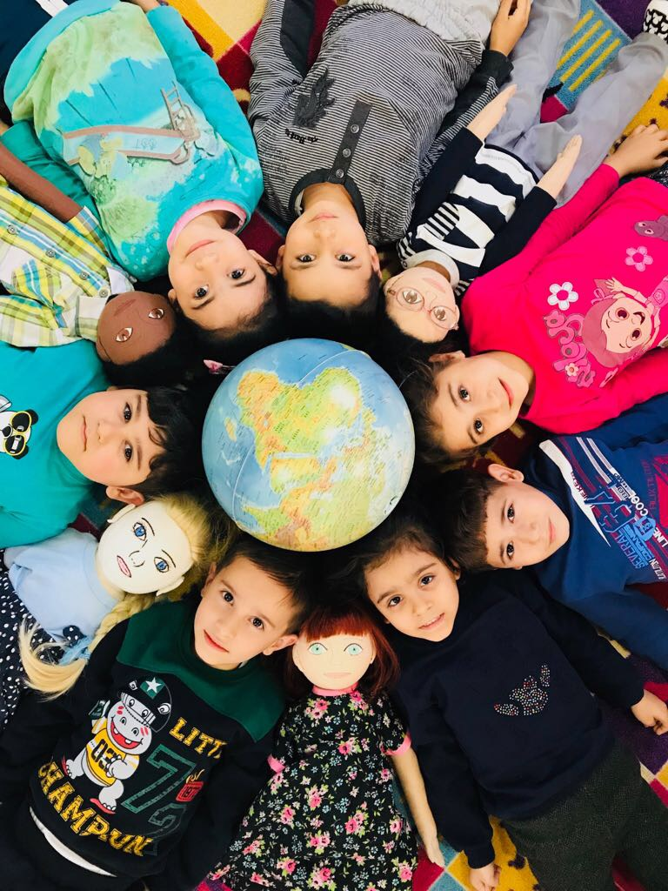

DOLL PROFILE 3
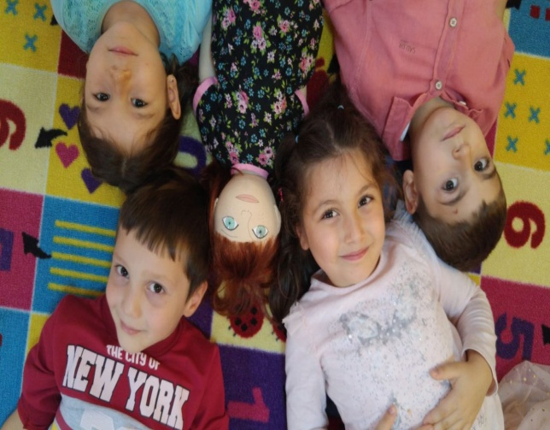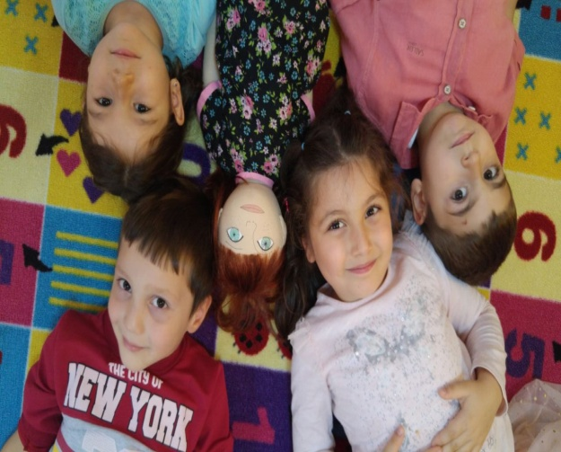
NAME : YASEMIN
FAMILY :
She lives in Izmir with father, mother and brother. Her mother is Turkish. Her father is Greek. She has younger brother She lives in private house which belongs to her family. She has very nice room in their house.
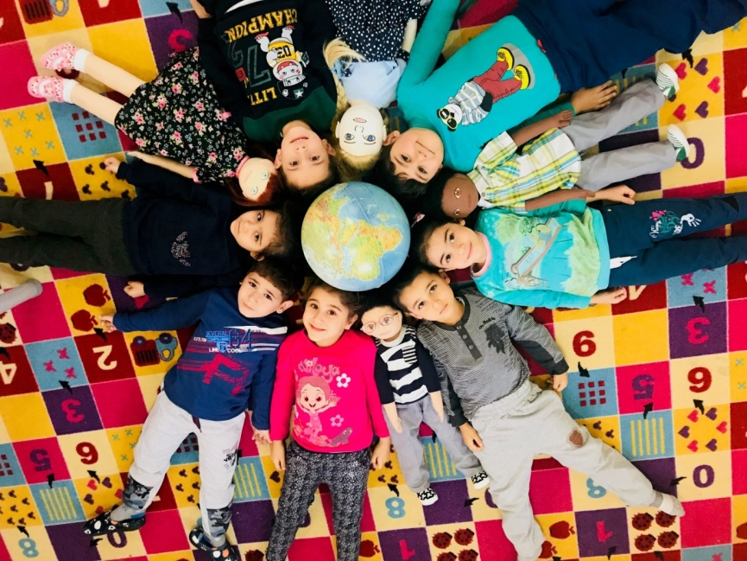
THINGS HE LIKES
- She likes painting.
- She likes playing her dolls.
- She likes riding scooter.
- She prefers to play alone.
THINGS HE DOES NOT LIKE
- She does not like sharing.
- She does not eat some meals. She loves eating hamburger.
- She doesn’t like eating fish and vegetables.
- She hates giving her dolls to other children.
- Her most favourite colors are pink and purple. 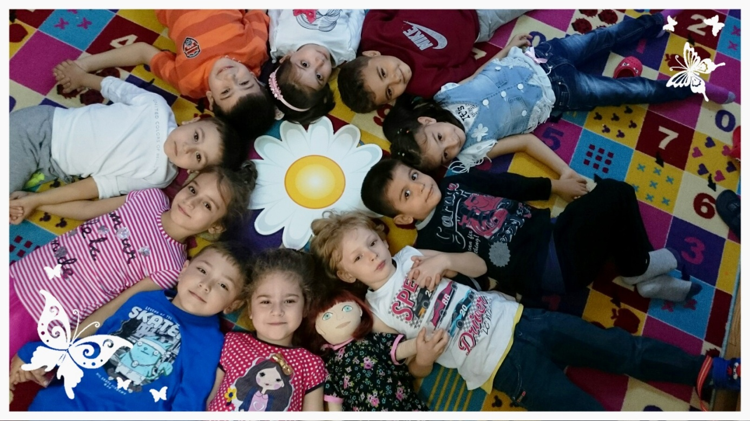
DIFFICULT TO DO
- She can’t speak fluently some words.
- She can’t join his friends on games.
- One of her leg is shorter than other,
- That is why she has walking problem.
- She can’t dance. She is so sorry about that. This problem causes disability of social skills.
- She fears darkness and thunder.
HIS RECENT STORY
Her father works ın Izmir seaport. Her father has to go out foreign country. Her mother is nurse in an hospıtal. Her grandfather and grandmother lives in Greece. That is why she misses a lot. Since her bırth, having short leg is most important problem.

DOLL PROFILE 4
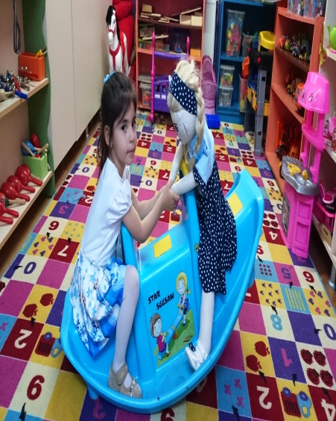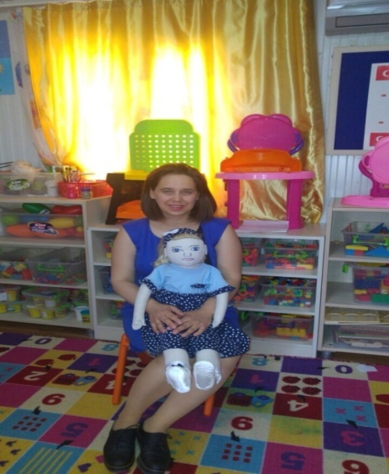
NAME : ESMA
FAMILY :
- Her mother and her father are Turkish.
- Her father is office worker
- Her mother is housewife
- She has grandfather and grandmother ın a village.
- She has older sister.
- She lives with her family in a flat.
- She speaks just Turkish.
THINGS SHE LIKES
- She loves numbers
- She likes playing puzzle
- She likes watching wash machine when it works
- She likes repetitive things
- She loves music
- She loves horse especially ponies
- She is obsessed with the blue

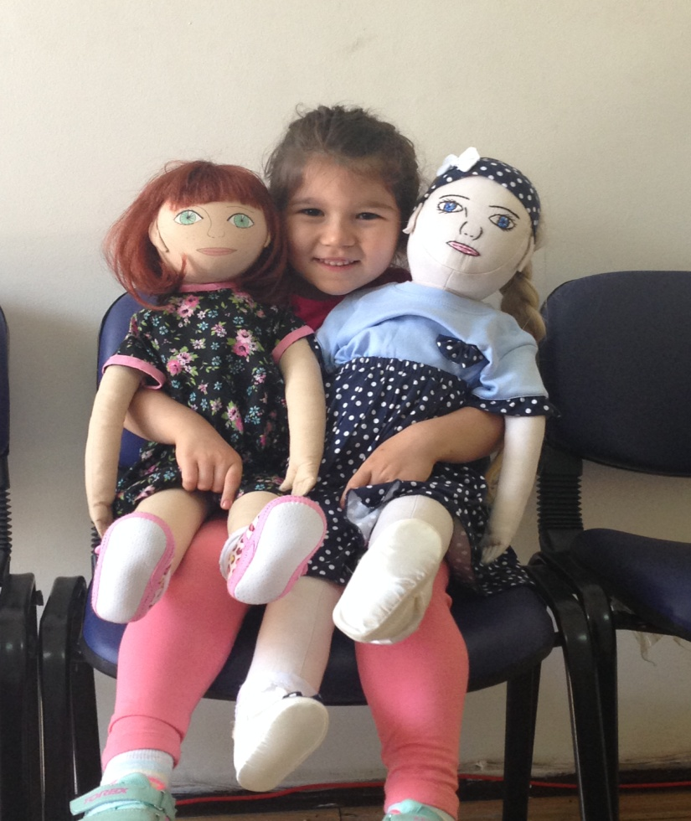

THINGS SHE DISLIKES
- Playing group games.
- Contact other people.
- She is not interested her environment

DIFFICULT TO DO
- She is autistic.
- She can’t join his friends on games.
- She has social problems.
- She screams sometimes.
- She gets agressive when she mets people who she doesn’t know.
- She has contact just her teacher in class.
- She prefers being alone.
- She only plays on her own.
- She always ask interest one on one.

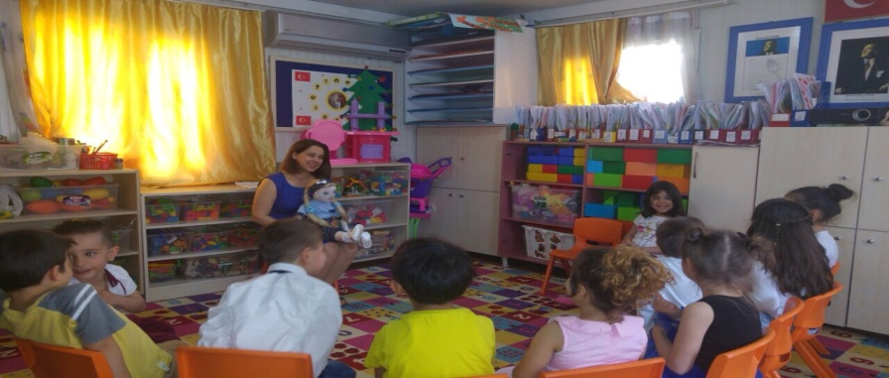

HER RECENT STORY
Her family realized her differencies when she was 2 years old. They went to children doctor. They learned that she is autistic. She began to go to rehabilitation. She had many many problem when she started to come to our kindergarten. Her teacher and her family always keep in touch for solve her problem. She loves being village where her grandparents live ; because she feels in peace there.
