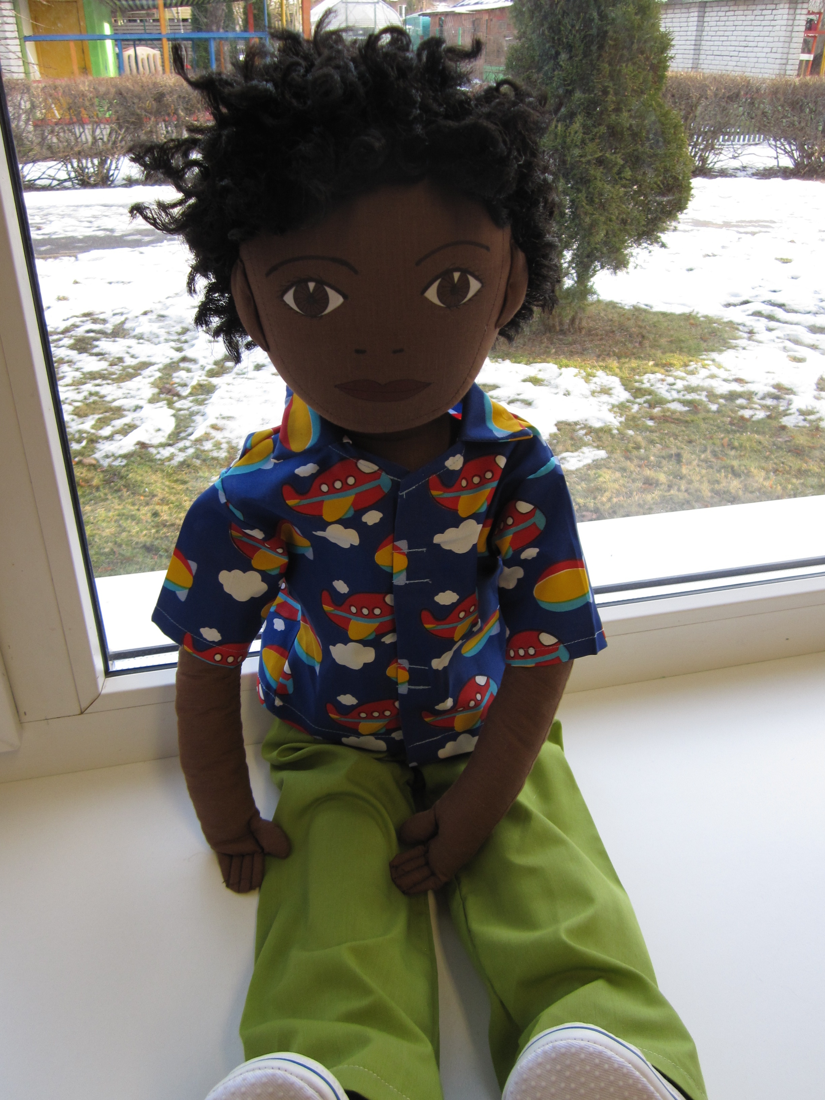
Name: Ibrahim
Family: Ibrahim lives with his mother and father. He has a older sister and a younger brother.
Cultural background: Ibrahim was born in the North- African country Libyans. Ibrahim’s family are muslims and they follow muslim traditions. Ibrahim’s mother and older sister wear head scarf when they are outside home. Ibrahim’s family don’t eat pork meat and the family celebrates every year ramadan during what the families older child and parents fast. Ibrahim speaks arabian language, some words in english and some words in estonian.
Where he lives: Family lives in Lasnamäe in 2 rooms apartment.
Likes/dislikes/ is difficult: For Ibrahim is difficult to speak in estonian language and communicating with other children. In kindergarten Ibrahim don’t understand everything that is done or said.
Ibrahim does not like snow and cold weather. He is used to live is warm climate.
Ibrahim likes to look and read books. He likes to go to the meetings with people from his homecountry. On these meetings he can communicate and play with children his age who can speak and understand arabic language.
Food he likes, dislikes: Ibrahim likes meals made from chicken and different vegetable salads. He likes different Libyans desserts and fruits.
Ibrahim is used to eat spicy food, he likes it very much. Ibrahim does not like Estonian food. He does not eat potatoes and sauce. Ibrahim does not like kindergarten meals because those are very different from the dishes he is used to and what they prepare in his home.
Fears: Ibrahim is afraid of the dark and loud noices. He sleeps in the same bed with his mother and father because he is afraid to sleep alone.
Physical peculiarity: Ibrahim has dark skincolor and dark black curly hair. He has dark eyes. Ibrahim can sing very good.
Recent history: In Ibrahim’ s homecountry Libyans is currently taking place a civil war and therefore many people escape from that country to Europe. Ibrahim came with his family 1 year ago to Estonia. At first they lived in refugee shelter but now the family lives in 2 room private apartment in Tallinn, Lasnamäe.
In Libyans Ibrahim’s father was a doctor and mother worked in library. In Estonia it is very difficult for Ibrahim’s father to find a job and it the family struggles for that reason. Ibrahim started to go to kindergarten recently. It is very difficult for Ibrahim to find new friends in kindergarten. He can not communicate with others because he does not speak estonian. Ibrahim is worried because he has different clothes than everyone else. Families clothes came from helpers. Ibrahim’s family is having very difficult times adapting because they feel excluded.

