NAME: MARIA 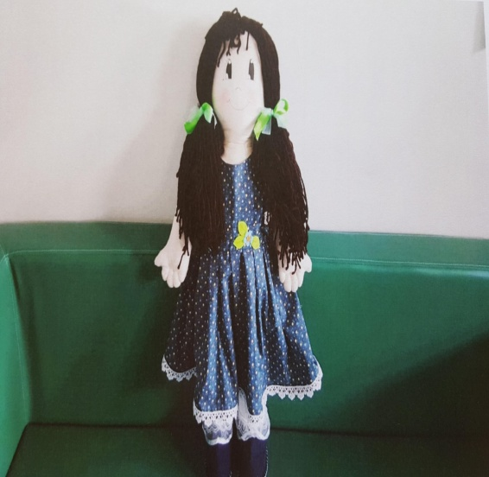

AGE: 6
FAMILY STRUCTURE: MOTHER AND SISTER
CULTURAL BACKGROUND: MARIA LIVES IN BATTIPAGLIA WITH HER MOTHER AND HER SISTER. MARIA’S FATHER LIVES IN MAROCCO AND HE IS A CARPENTER. FIVE YEARS AGO MARIA LIVED IN THE SUBURB IN MILANO WHERE HER GRAND MOTHERLIVES. MARIA’S MOTHER AND GRAND MOTHER COME FROM ALBANIA. SHE SPEAKS ITALIAN AND ALBANIAN.
WHERE SHE LIVES: SHE LIVES IN BATTIPAGLIA IN A SMALL FLAT .
LANGUAGE: SHE SPEAKS ITALIAN AND ALBANIAN.
WHAT DOES SHE LIKES/DOESN’T LIKE: SHE LIKES PLAYING WITH DOLLS AND PLAYING WITH COOKING GAMES. SHE LOVES PLAYING WITH LORELLA, SHE LIVES NEAR HER HOME, INFACT SHE HOPES THAT LORELLA WILL GO TO HER SCHOOL BECAUSE SHE GOES TO AN OTHER SCHOOL ( RAVENNA STREET), AND GOING TO SCHOOL TOGETHER WOULD BE GREAT. SHE LIKES PLAYING IN THE PARK AND SINGING BUT SHE KNOWS ONLY ALBANIAN SONGS SO NOBODY UNDERSTANDS HER. MARIA’S MOTHER WANTS THAT MARIA GOES TO THE GYM, BUT SHE DOESN’T LIKE IT BECAUSE SHE HAS PROBLEMS IN WALKING .
DIFFICULTY: SHE LIMPS JUST A LITTLE BIT.
FOOD: SHE LIKES CHOCOLATE CAKE AND SHE DOESN’T LIKE PASTA WITH BEANS.
FEARS: SHE IS AFRAID OF DOGS AND TO STAY ALONE AT HOME.
CURRENT SITUATION: SHE HASN’T GOT MANY FRIENDS BECAUSE HAS RECENTLY ARRIVED IN BATTIPAGLIA AND HER MOTHER DOESN’T SPEAK ITALIAN VERY WELL SO SHE DOESN’T MEET MANY PEOPLE. MARIA SUFFERS BECAUSE CHILDREN DON’T ACCEPT HER BECAUSE SHE DOESN’T SPEAK ITALIAN VERY WELL AND SHE ISN’T FAST IN MOTION GAMES.
STORY
ONE DAY MARIA STARTED TO CRY AND DIDN’T GO TO SCHOOL. THE GIRLS IN HER CLASSROOM WERE PLAYING WITH DOLLS AND MARIA ASKED THEM TO PLAY BUT ONE GIRL SAID THAT SHE COULDN’T BECAUSE SHE LIMPED. AFTER THAT MARIA STARTED TO CRY BECAUSE SHE DISCOVERED HER DISABILITY. SHE WENT TO HER TEACHER AND TOLD HER THAT THE GIRLS OF THE CLASSROOM DIDN’T WANT TO PLAY WITH HER. THE THEACHER EMBRACED MARIA AND ASKED SOME QUESTIONS IN THE CLASSROOM.

- TEACHER
- IS SOMEONE HAVING A BAD BEHAVIOUR? WHO?
- HAVE YOU EVER SEEN SIMILAR SITUATIONS?
- IS IT CORRECT TO REJECT A PERSON DIFFERENT FROM YOU?
- DOES SOMEONE KNOW SONGS IN OTHER LAGUAGES?
- WHAT DO YOU DO TO HOST PEOPLE COMING FROM OTHER COUNTRIES?

- CHILDREN
- CHILDREN SAID THAT GIRLS HAD A BAD BEHAVIOUR
- CHILDREN SAID THAT THEY KNEW MANY PEOPLE LIMPING BUT NOBODY SINGING IN ALBANIAN.
- CHILDREN SAID THAT IT WASN’T CORRECT TO REJECT SOMEONE ONLY BECAUSE DIFFERENT.
- CHILDREN SAID THTAT THERE WERE MANY GAMES THAT THEY COULD DO WITH MARIA.
- CHILDREN SAID WE HAVE TO ACCEPT PEOPLE AS THEY ARE.

