TALATPAŞA ORTAOKULU

EVERY CHILD IS SPECIAL

DOLL BOOK
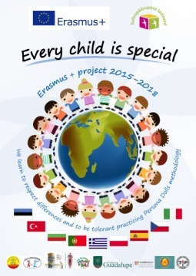

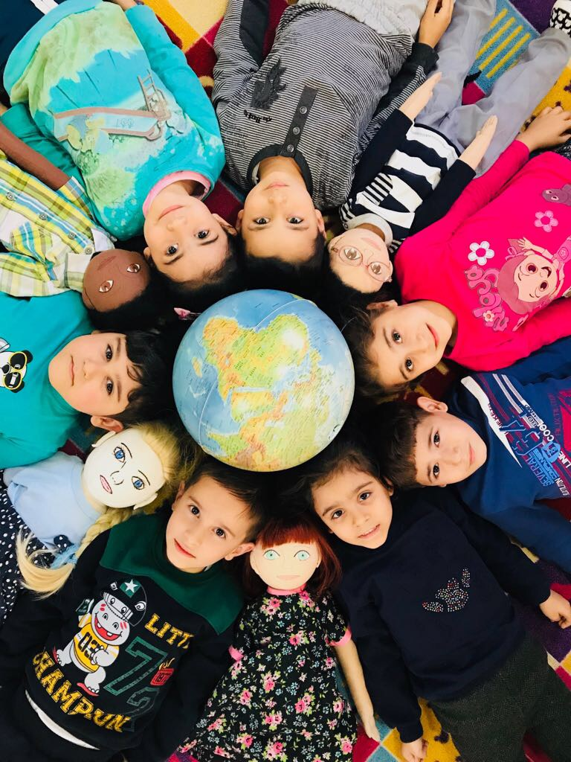

DOLL PROFILE 1
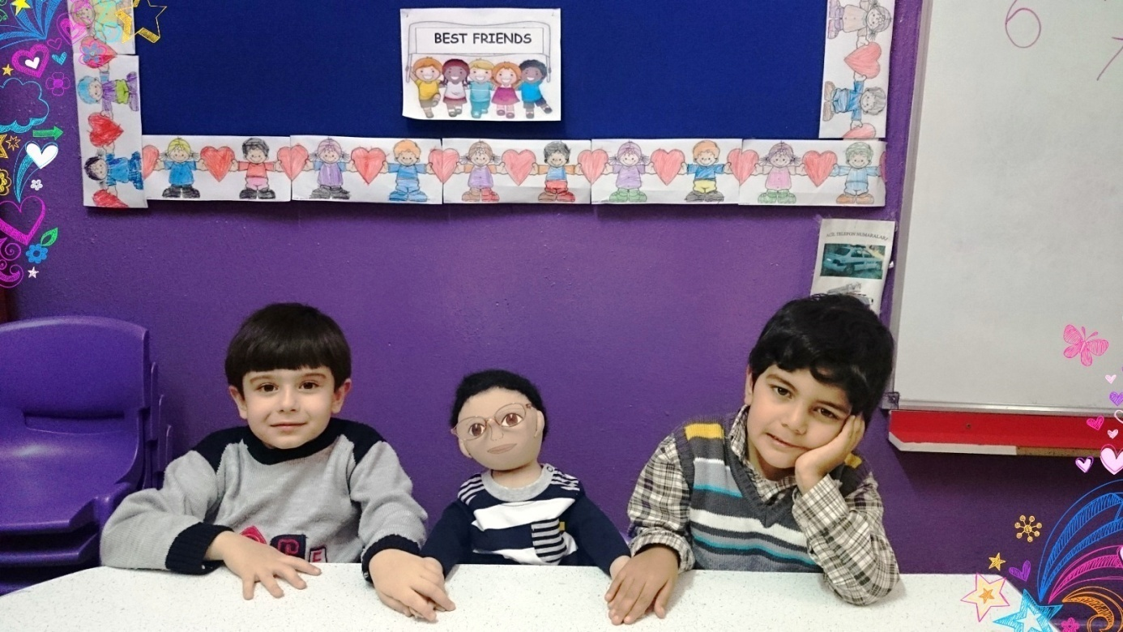
NAME : Bora
FAMILY :
His mother and father divorced. He has an older brother and younger sister.He lives with his mother and younger sister in an apartment flat. He speaks just Turkish which is his native language. His grandfather ve grandmother lives far city from him; that’s why he misses so much.

THINGS HE LIKES :
- Playing football.
- Playing with lego.
- Swimming.
- Help his friends and share with his friends.
- His favourite colour is blue.

THINGS HE DOESN’T LIKE :
- Wearing glasses.
- Eating vegetable.
- Losing in games.

DIFFICULT TO DO FOR HIM :
- He hardly try to play football because of he wear glasses.
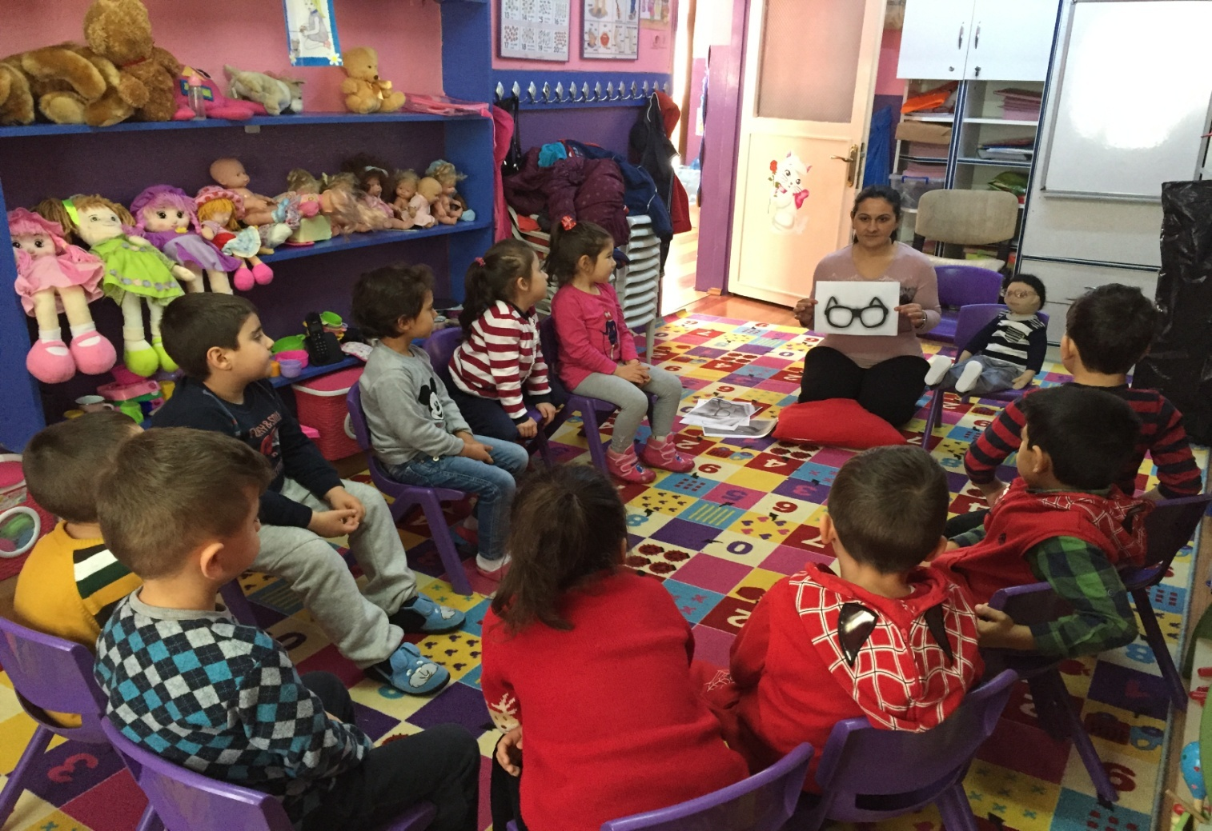

RECENT STORY :
His family moves from another city of Turkey which name is Adana to Izmir for job opportunities. They have to live in an apartment flat. He can’t play outside unlikely he could play outside in a town which he came. Bora misses so much both playing outside and old friends. He loves playing football but he has problem for it that wearing glasses.
Another problem is his mother and father divorced. That makes him unhappy and unpeaceful. Also he misses so much his grandfather and grandmother who lives in a town which he came.

