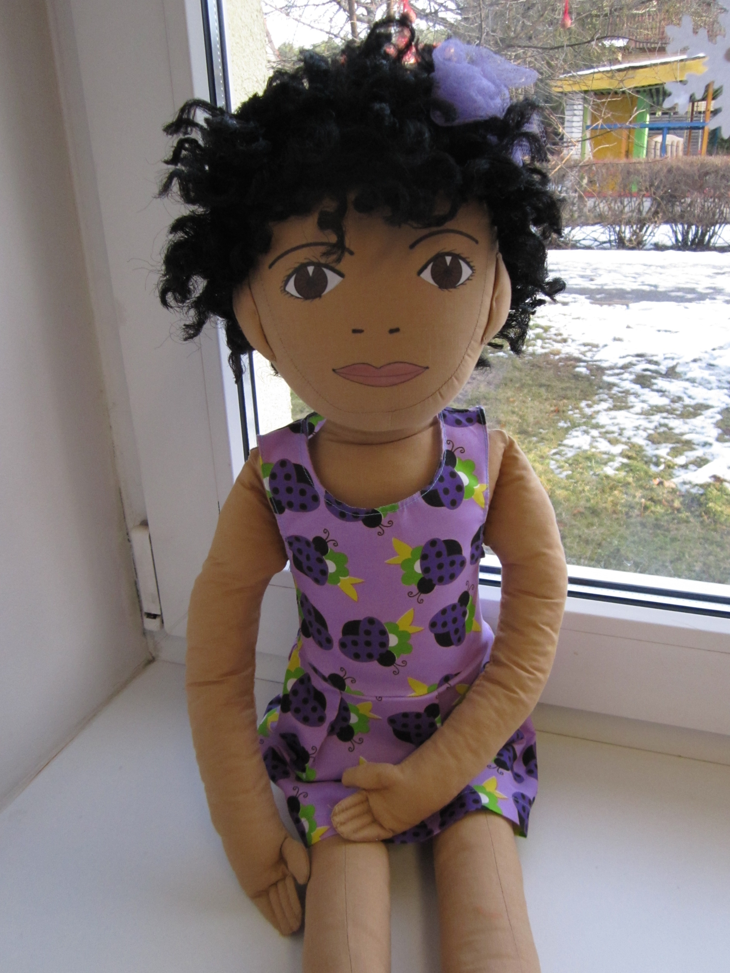
Name: Marie (Marii)
Family: Marie lives with mother and father. She is the only child in family.
Cultural background: Marie’s father is french businessman and her mother is estonian. Marie speaks in estonian and french.
Where she lives: Marie lives in Estonia, Viimsi parish (near Tallinn). Her family lives in a big private house.
Likes/dislikes/is difficult: Marie likes to sing. She is attending ballroom dance lessons and she also participates in ballroom dance competitions. Marie likes to participate in dance competitions and wear sparkly dance dresses.
At home Marie likes to play princess games and beauty pageant.
Marie doesn’t like if other children and adults touch her hair. Her curly hair look different from estonian children’s hair so everyone want to touch her hair all the time. Marie doesn’t like to get dirty and because of that she never wants to play in sandbox.
Food she likes/dislikes: Marie really likes to eat pasta and sushi. She doesn’t like lemonade and sour cabbage. Marie never eats meat with fat.
Fears: Marie is afraid that she will feel bad and weak and mother is not with her that time.
Physical peculiarity: Marie has diabetes. She is in very good physical shape. Marie is very talented kid – she can handle everything perfectly.
Recent history: Recently her family found out that Marie has diabetes. Diabetes is so serious that Marie has to carry insulin syringe with her in kindergarten.
Mother thinks that Marie can’t attend ballroom dance lessons anymore because she is sick and weak. Marie still wants to attend dance lessons and she doesn’t agree to quit dance competitions.
Marie has always been very good and talented kid. She can handle everything perfectly. Marie is used to get praised constantly. Because of that she doesn’t want other kids to find out about her diabetes. She doesn’t want other kids think that she is sick and weak.

