Erasmus + project „Every child is special“ questionnaire for parents

- Evaluate your knowledge about project activities
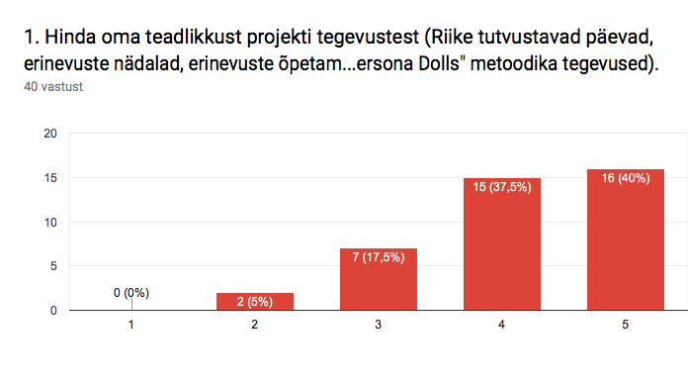

Parents knowledge about project activities is quite high.

- Mark the statements you find true.
-tolerance has increased among children
-careing has increased among children
-children problem solving skills have improved
-children have gained new knowledge about other cultures and nations
-children are interested to take part in project activities
-I am satisfied that kindergarten takes part in transnational projects
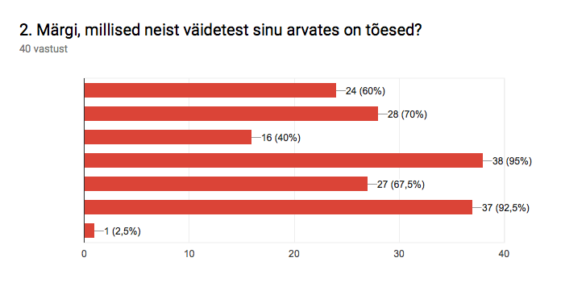
Parents evaluated highly that children have gained new knowledge about other cultures and nations. Parents mainly evaluated to be satisfied that kinderagarten takes part in transnational projects.
Parents mainly pointed out that tolerance and careing has increased among children.

- Have you participated in project activities?

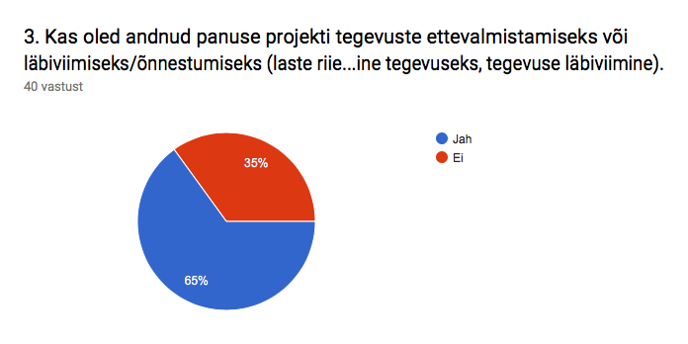
- Does your child talk about project activities at home?

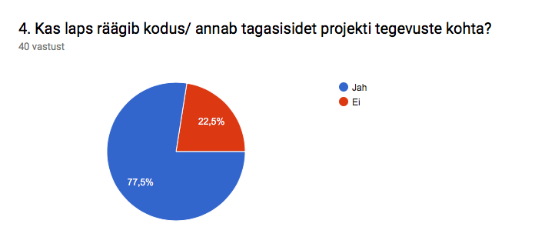

- Is it important for you that kindergarten will take part in similar projects in the future?

